Lab 1. Exercise 3 - Scientific Measurements

Overview
During this exercise, you will be measuring length, volume, temperature, and mass of different objects. You will become familiar with the use of different devices to measure these properties and determine the accuracy and precision of the instruments and your measurements. You will learn the units and conversions in the metric system, as well as practice proper recording of data.

Learning objectives
- Be able to measure and calculate the linear dimensions of objects using the metric system.
- Be able to measure volumes of liquids using different laboratory vessels.
- Be able to determine the precision and accuracy of measurement of a beaker, a graduated cylinder and a graduated pipette.
- Be able to measure the mass of a solid using a double-beam balance.
- Be able to use a thermometer to measure the temperature of a liquid.

Materials and equipment
- Sugar
- Ice water
- Boiling water
- Small plastic scoops or spoons
- Metric rulers
- Geometric shape cut outs (cardboard or hard plastic)
- Large test tubes
- Bottles for water samples (glass or plastic)
- 100 ml beaker with volume markers
- 250 ml beaker
- 100 ml graduated cylinder
- Double-beam balance
- 500 ml beakers
- Thermometer
- Hot plate

Background
Measurement is the process whereby we can determine physical quantities, such as amounts of liquid, amount of matter in an object and amount of heat of a body. When conducting scientific research, it is important to use a system of measurement that is based on universal standards and is consistent. The metric system allows us to accurately compare, communicate and interpret our results. The metric system is a decimal system, which means it is based on units of ten.
When making a measurement, the result is expressed with a numeral followed by a unit to indicate length, mass, or volume. The base unit for common measurements are shown in Table 1.
Property | Description | Unit | Unit symbol | Measuring device or instrument
Mass | How much do I have? | grams | g | Electronic balance
Volume | How much space does it occupy? | liters | L | Graduated cylinder
Volume |  | milliliters | mL | Pipet
Volume | H | cubic centimeters | cm³ | Burette
Temperature | How hot? | Degrees Celsius | ˚C | Thermometer
Table 1. Common Measurement Units

When measuring large or very small amounts, prefixes that relate to a specific power of ten can be added to the “stem” or unit symbol; some of the most commonly used prefixes are presented in Table 2.
Table 2. Commonly used prefixes and their values
Prefix | Exponential Value | Length | Mass | Volume
blank | 10⁰ | Meter | Gram | Liter
centi | 10⁻² | centimeter | centigram | centiliter
milli | 10⁻³ | millimeter | milligram | milliliter
micro | 10⁻⁶ | micrometer | microgram | microliter
Kilo | 10³ | Kilometer | Kilogram | Kiloliter
Before continuing with the procedures section, watch the following videos explaining how to measure volumes and uncertainty in measurement.
Measuring Volume (BioNetwork) (https://youtu.be/2WqAYFSzCUo)

Uncertainty in measurement (https://youtu.be/LWAHqp1BmSM)

Concepts to understand
Make sure you have a clear understanding of the following concepts after reviewing the provided videos and reading materials:
- Measurement
- Units in the metric system
- Data
- Uncertainty
- Precision
- Accuracy
- Meniscus
- Kilo, Hecto, Deca, deci, centi, milli, micro, nano

Procedures for measuring
Every student must do all the calculations, record all the results and draw the graphs during the lab activity.

Measuring length and width of different geometric shapes
Steps
- Obtain two different geometric shape cutouts from your instructor.
- Using the metric ruler provided in your workspace, measure the length and width of each one of the shapes.
- Record your measurements in the table below. Make sure you use significant figures, so in the example below (Figure 1), the ruler markings are every 0.1 cm. The correct reading is 4.58 cm, the two first digits, 4.58 are known exactly, the 4.58 is uncertain. When measuring, you record all the digits that are known exactly, plus the first one that is uncertain.

Figure 1. Measuring length of a cut out rectangle
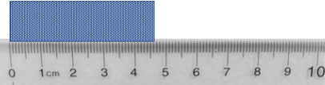
- Using the values you obtained, calculate the area of the geometric shapes. You calculate the area of a square or a rectangle, by multiplying width X length. Record your results in the following table and don’t forget the units!
If multiplying or dividing measured values, the result should be reported with the lowest number of significant figures used in the calculation.
For example: 4.58 cm X 2.53 cm = 11.59 cm² (omit the other decimals you obtain when you perform the multiplication).

Table 3. Shape measurement
Shape | Width | Length | Area
enter in cm | enter in cm | enter in cm | enter in cmext.
enter in cm | enter in cmtext. | enter in cmt. | enter in cm ext.

Measuring the Volume of a sample of water
Steps:
- Obtain your water sample from your instructor.
- Pour your water sample into the 100 ml beaker.
- Measure the volume of water in the beaker and record this measurement in the table below. Remember to write the numerical value and the units, as well as the significant figures.
- Carefully transfer the water in the beaker into the 100 ml graduated cylinder.
- Measure the volume of water in the 100 ml graduated cylinder and record your measurement in the table below. Remember to write the numerical value and the units, as well as the significant figures.

Table 4. Volume measurement
Vessel | Volume measured
100 ml beaker | Click or tap to enter volume.
100 ml graduated cylinder | Click or tap to enter volume.
- Do the measured values have the same number of significant figures? Explain your answer (why yes, or why no)
Click or tap here to enter text.

Measuring Mass
- Use a double-beam (Figure 2) balance to obtain the mass of a 250-mL beaker. Record the mass in the table below. Remember to write the numerical value and the units.
- Remove the beaker from the balance and add three scoops of sugar to the beaker.
- Obtain the new combined mass of the beaker and the sugar. Record this new mass in the table below. Remember to write the numerical value and the units.
- Use your two measurements to determine the mass of the sugar and record it in the table below. Remember to write the numerical value and the units.

Figure 2. Double-beam balance
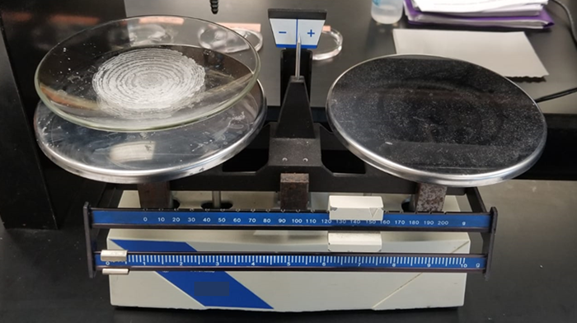
“Balance” by Justin Morales, Laura Pessoa, Jennifer Sanchez and Delilah Ramos is licensed under CC BY 4.0

Table 5. Mass measurement
Sample | Mass
250 ml beaker | Click or tap to enter mass.
250 ml beaker + 3 scoops of sugar | Click or tap to enter mass.
Sugar | Click or tap to enter mass.

Measuring Temperature
Steps:
- Obtain a thermometer from your instructor. Before making your measurements, examine the markings on the thermometer.
- Obtain three 500 ml beakers.
- Fill one beaker with tap water
- Half fill another beaker with tap water, the add ice to fill beaker.
- Obtain hot water from your instructor. ***Handle the beaker with insulating gloves***
- Measure the temperature in each one of the beakers and record your results below. Remember to write the numerical value and the units.

Table 6. Temperature measurement
Sample | Temperature | Unit
Tap water | Click/tap to enter. | Click/tap to enter.
Hot water | Click/tap to enter. | Click/tap to enter.
Ice water | Click/tap to enter. | Click/tap to enter.
- Compare your results of each measurement with those of your other group members. Are the measurements close in value? What does this tell you about the precision of your measurements as a group?
Click or tap here to enter text.

First and last name:
Enter your first and last name (required).
Follow your instructor's directions in renaming and submitting your lab.

Copyright and attribution
This work is licensed under a Creative Commons Attribution 4 International. It was previously published as “Water in your neighbourhood: a model for implementing a semester-long course-based undergraduate research project in introductory biology,” in Education Inquiry, (2020) DOI:10.1080/20004508.2020.1716542 as an Open Access article with the Creative Commons Attribution-NonCommercial License. All figures have been modified.

Appendix 1 - Lab 1 Measurable Rectangles
Exercise 1. Measuring the length and width of geometric shapes. Chose any two shapes, make sure you record which shapes you chose, print them out and measure them. If you do not have a ruler with cm, print out the printable ruler given to you in the files.
Figure 1

Figure 2

Figure 3

Figure 4

Appendix 2 - Lab 1 Mass Measurements
Mass Measurements: Use the pictures below to record the values in Table 4 of your lab handout. Complete the calculations once you have entered the values.
The measurements were made on an electronic scale instead of a double beam scale.

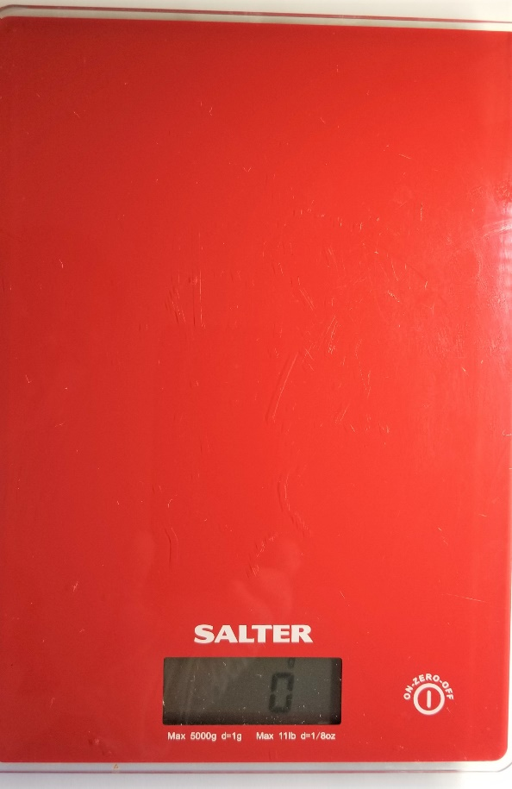1.Scale replacing the double-beam balance. The scale is turned on. Note the value “0” which should appear before using the scale.
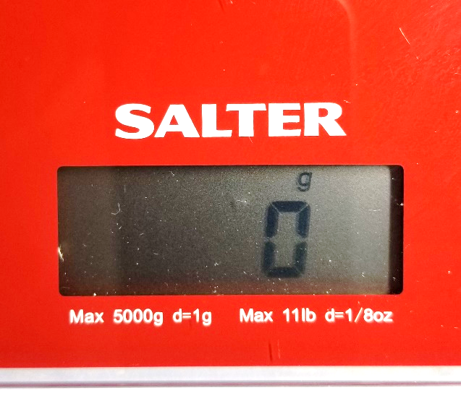Close up showing 0. Note the units are gram.

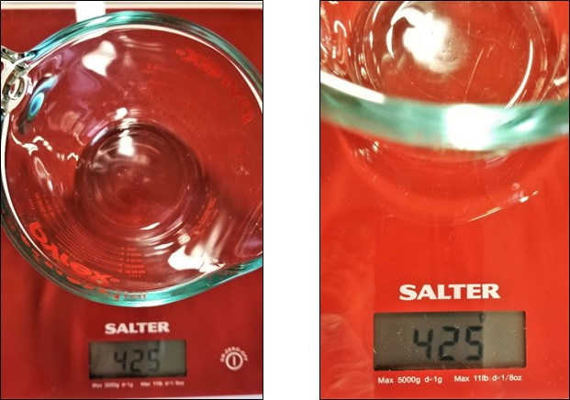
2. Pictures above are after the beaker has been placed on the scale. The picture on the right is a close up showing the measurement.
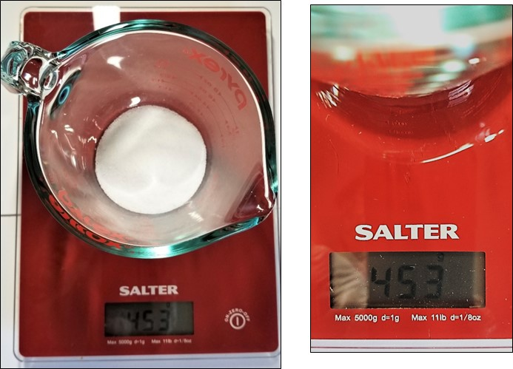
3. Pictures above are after adding three spoonsful of sugar to the beaker. Picture on the right is a close-up.

Appendix 3 – Lab 1 Thermometer Measurement
Use the following thermometers to record results in Table 6 in your lab handout. Make sure you record the temperature using significant figures
Figure 1
Tap water
Figure 2

Boiling water
Figure 3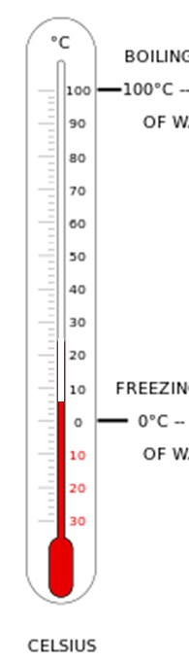
Ice water

