Lab 7 Exercises 1 to 4 - Meiosis and Trait Inheritance

Overview
This lab will introduce students to the purpose of meiosis. Students will also learn how chromosomes segregate according to Mendelian laws.

Learning objectives

By the end of this lab, students will be able to:
- State the purpose of meiosis
- Differentiate mitosis and meiosis
- Explain the difference between haploid and diploid cells
- Describe key events that occur in the stages of meiosis I and meiosis II
- Explain the rationale for using a Punnett square
- Interpret pedigree charts

Materials and equipment

In-person labs
- Meiosis sorting cards cardstock cutouts (for Exercise 1)
- BabyMaker reference sheet (PDF file) (for Exercise 3)
- BabyMaker web app (http://ct.excelwa.org/ctfiles/apps/babymaker.html) (for Exercise 3)

Online labs
PowerPoint slides with the filename Meiosis Sort Cards_5MLRjSM_PPT
Every attempt will be made to accommodate any student who need other options to complete the activities and questions as described. If you need assistance, please contact the instructor as soon as possible to discuss necessary accommodations and/or contact the Office for Students with Disabilities at (718) 482-5279 or go to room M-102. To request a device for distance learning, please contact the Student Information Center (SIC) at LaGuardiaNews@lagcc.cuny.edu (Be sure to tell them your EMPL ID#.

Pre-lab Mitosis Exercise
Students should complete the assigned EdPuzzle video on mitosis.

Exercise 1: Meiosis sorting activity
In this activity students will work in groups of 3 to 4 to demonstrate meiosis beginning with interphase.
For online laboratories, students will use the Meiosis Sort Cards_5MLRjSM_PPT PowerPoint file and order the chromosome tiles accordingly.
Students can work independently or randomly grouped (3 to 4 students) in breakout rooms.
Exercise 2: Fertilization

A. Comparing Mitosis and Meiosis
The diagrams in Figure 1 show mitosis and meiosis after DNA has been replicated and wound tightly into sister chromatids. The dotted lines represent cytokinesis.
Figure 1. Mitosis and meiosis

A
B

Activity A questions
- In Figure 1, which column shows meiosis and which column shows mitosis.
Meiosis Click/tap to enter A or B Mitosis Click/tap to enter A or B
- What are some similarities between cell division by mitosis and cell division by meiosis?
Click or tap here to enter text.
- Complete Table 1 to describe some important differences between mitosis and meiosis.

Table 1. Differences between mitosis and meiosis
Characteristic | Mitosis | Meiosis
Number of daughter cells | Click or tap here to enter text. | Click or tap here to enter text.
Type of cells produced | Click or tap here to enter text. | Click or tap here to enter text.
Genetic differences or similarities between daughter cells | Click or tap here to enter text. | Click or tap here to enter text.
Number of cell divisions | Click or tap here to enter text. | Click or tap here to enter text.

B. Meiosis – Cell Divisions to Produce Haploid Gametes
Before meiosis, the cell makes a copy of the DNA in each chromosome. Then, during meiosis there are two cell divisions, Meiosis I and Meiosis II. These two cell divisions produce four haploid daughter cells.
Meiosis I is different from mitosis because each pair of homologous chromosome lines up next to each other and then the two homologous chromosomes separate.
Figure 2 shows Meiosis I for a cell with a single pair of homologous chromosomes. The stripes on the chromatids of one of the chromosomes indicates that this chromosome has different alleles than the other homologous chromosome.
Meiosis I will produce daughter cells with half as many chromosomes as the parent cell, so the daughter cells are haploid. Each daughter cell has a different chromosome from the original pair of homologous chromosomes.

Activity B questions
Examine Figure 2 which shows a diploid cell (2n) with a pair of homologous chromosomes. After completing meiosis I, the resulting cells each contain one chromosome and are now considered haploid (n).
Figure 2. Meiosis I

- Do the chromosomes in the two daughter cells produced by Meiosis I have the same alleles for each gene? Explain your reasoning.
Click or tap here to enter text.

Meiosis II is like mitosis since the sister chromatids of each chromosome are separated. As a result, each daughter cell gets one copy of one chromosome from the pair of homologous chromosomes that was in the original cell. These haploid daughter cells are the gametes.
- Use asterisks (*) to indicate the cells in Figure 3 that represent sperm produced by meiosis.
Figure 3. Meiosis II
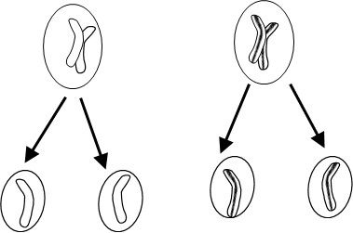

C. Meiosis and fertilization
Almost all the cells in your body were produced by mitosis. The only exceptions are the gametes – sperm or eggs – which are produced by a different type of cell division called meiosis.
During fertilization the sperm and egg unite to form a single cell called the zygote which contains all the chromosomes from both the sperm and the egg. The zygote divides into two cells by mitosis, then these cells each divide by mitosis, and mitosis is repeated many times to produce the cells in an embryo which develops into a baby (Figure 4).
Figure 4. Meiosis and fertilization
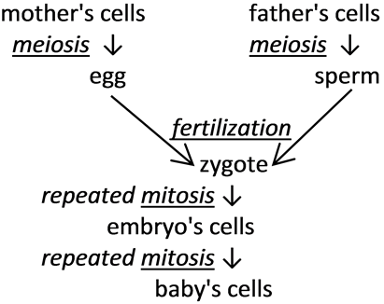

Activity C questions
- Each cell in a normal human embryo has 23 pairs of homologous chromosomes, for a total of 46 chromosomes per cell. How many chromosomes are in a normal human zygote? Explain your reasoning.
Click or tap here to enter text.
- What would happen if human sperm and eggs were produced by mitosis? Explain why this would result in an embryo, which had double the normal number of chromosomes in each cell.
Click or tap here to enter text.
A human embryo with that many chromosomes in each cell would be abnormal and would die before it could develop into a baby. So, gametes cannot be made by mitosis.
For questions 3 and 4, click or tap number to enter the correct number.
- Each human sperm and egg should have number chromosomes, so fertilization will produce a zygote with number chromosomes. This zygote will develop into a healthy embryo with number chromosomes in each cell.

- Each sperm and each egg produced by meiosis has only one chromosome from each pair of homologous chromosomes. When a sperm and egg unite during fertilization, the resulting zygote has number pairs of homologous chromosomes.

For each pair of homologous chromosomes in a zygote, one chromosome came from the egg and the other chromosome came from the Click or tap to enter text .

D. Modeling Meiosis to Understand How Meiosis Produces Genetically Diverse Gametes
To model meiosis, you will use the same pairs of model homologous chromosomes that you used to model mitosis. A person with these chromosomes would have the genotype AaSs.
Table 2 below represents phenotype, and proteins produced by genes for melanin production (A), hemoglobin structure (S).

Activity D questions
What phenotypic characteristics would a person with this genotype have (AaSs)? Highlight in yellow or underline the appropriate phenotypic characteristics in Table 2.
Table 2. Phenotypic characteristics
Genotype | → | Protein | → | Phenotype (characteristics)
AA or Aa | → | Enough normal enzyme to make melanin in skin and hair | → | Normal skin and hair color
aa | → | Defective enzyme for melanin production | → | Albino (very pale skin and hair color)
SS or Ss | → | Enough normal hemoglobin to prevent red blood cells from becoming sickle shaped | → | Normal blood (no sickle cell anemia)
ss | → | Sickle cell hemoglobin | → | Sickle cell anemia

In this activity, you will begin modeling meiosis with only one pair of the model chromosomes shown below in Figure 5.
Figure 5. Modeling Meiosis
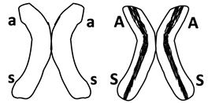
- Use Figure 6 below to draw and label the chromosomes in each cell that is produced by Meiosis I and by Meiosis II.
For online classes you may use the “scribble” drawing tool.
Figure 6. Meiosis and Meiosis Drawing
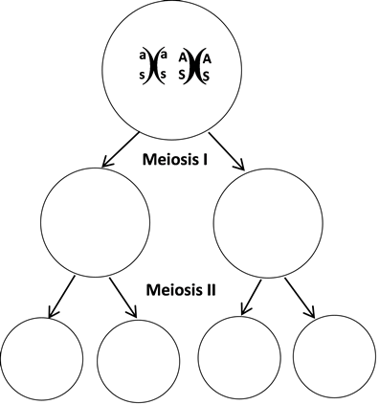
- Suppose you were asked to model meiosis, beginning with a diploid cell that has the alleles AaSs. The haploid gametes produced by meiosis would have which alleles? Mark one.
☐ As or as ☐ AASS or aass ☐ AaSs

E. Meiosis and the Law of Independent Assortment
Next, you will model meiosis using both pairs of model chromosomes. At the beginning of Meiosis I each pair of homologous chromosomes lines up independently of how the other pairs of homologous chromosomes have lined up. This is called independent assortment. As a result of independent assortment, at the beginning of Meiosis I, the chromosomes containing the as genes can be lined up on the same side as the chromosomes with either the recessive l gene or the dominant L gene. The L gene codes for an enzyme needed for alcohol metabolism (L). (See Table 3).

Activity E Question
Use your four model chromosomes to model Meiosis I and Meiosis II for both of the possible ways of lining up the model chromosomes at the beginning of Meiosis I. Record your results in Table 3 below.
For online classes you may use the “scribble” drawing tool.
Table 3. Modeling Meiosis I and II chromosomes
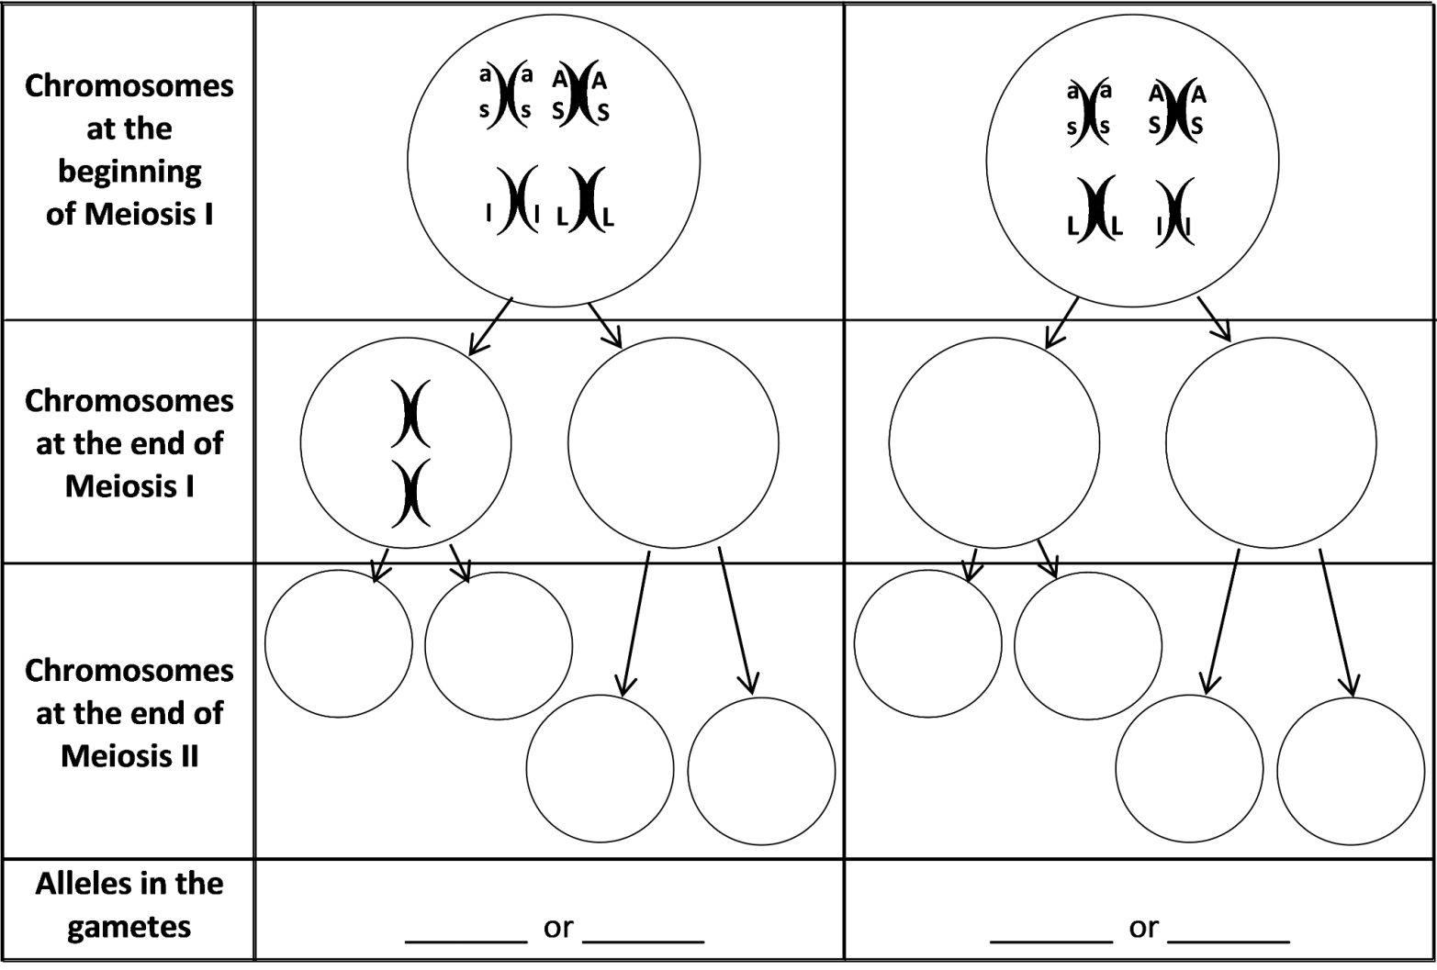

F. Meiosis and Genetic Variation
When a pair of homologous chromosomes is lined up next to each other during Meiosis I, the two homologous chromosomes can exchange parts of a chromatid. This is called crossing over.

Activity 7 Question
- On each chromatid of the chromosomes in the bottom row of Figure 7, label the alleles for the genes for albinism and sickle cell anemia.
Figure 7. Meiosis and Genetic Variation
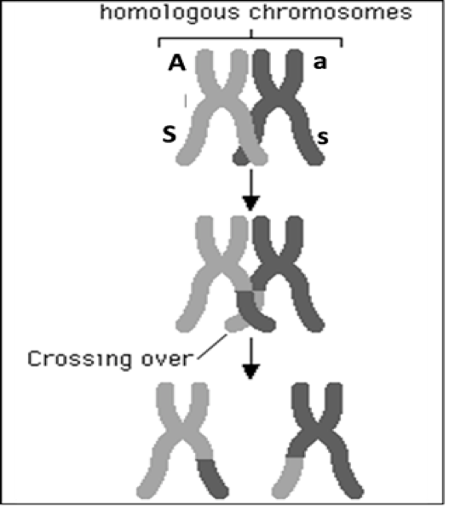

- When these chromosomes and chromatids separate during Meiosis I and II, this produces gametes with four different combinations of alleles for the genes for albinism and sickle cell anemia. Write the combinations of alleles in the different gametes in the boxes below.

enter text enter text enter text enter text

- Explain why different gametes produced by the same person can have different combinations of alleles for genes that are located on two different chromosomes.
Click or tap here to enter text.

- Explain why different gametes produced by the same person can have different combinations of alleles for two genes that are located far apart on the same chromosome.
Click or tap here to enter text.

Exercise 3: Punnett Square
The Punnett square can be used as a means to predict offspring based on parental genotypes. As shown in the Figure 8 below, alleles (different versions of a gene) are found in gametes of Parent A and B. The blue ovals represent the dominant allele and red stripes oval represent the recessive allele. Parent A is homozygous dominant for alleles 1 and 2. However, Parent B is heterozygous dominant. Parent B is also considered a carrier (has dominant and recessive allele).
Figure 8. Punnett Square of alleles
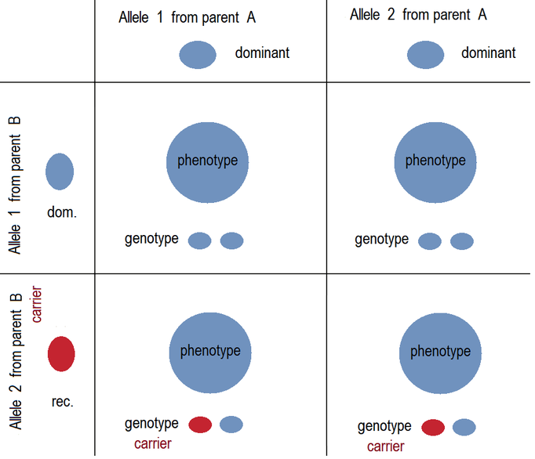
"Autosomal recessive inheritance - Carriers.png" by Sciencia58, used under a CC 0 1.0.
Stripes added to ovals.

BabyMaker activity
Do the activity with the BabyMaker web app (http://ct.excelwa.org/ctfiles/apps/babymaker.html).
Refer to the BabyMaker reference sheet (PDF)
In the BabyMaker activity, students begin by identifying their own genetic traits, answering a series of questions about their facial features. As they input their phenotype, an animated cartoon representation of themselves as a baby is created. Students then randomly generate a second baby to “cross” with, and proceed to create new generations of babies by filling in Punnett Squares and by reading probabilities of expressed traits from Punnett Squares.

Exercise 4: Pedigree Charts and Analysis
Pedigree charts can illustrate how traits are inherited across generations. The inherited traits, particularly those that are recessive, may be masked by the dominant phenotype. The recessive trait, however, will only appear if both parents have the defective gene. Geneticists perform a historical trace of genetic defects using pedigree charts. Geneticists can also predict future outcomes of possible crosses parental crosses. The pedigree charts below depict three pedigree charts (autosomal dominant, autosomal recessive and sex-linked recessive). Let us learn how to read a pedigree chart.

Reading Pedigree Charts
- Roman numerals represent generations beginning with Roman numeral I.
- Squares represent males. Circles represent females.
- If a square or circle is completely filled, it will represent an affected male or female, respectively.
- If a square or circle is half-filled, it will represent a male or female carrier, respectively.
- The horizontal line connecting circles and squares represent mating between male and female parents.
- The vertical line extending from horizontal line represents the offspring.
- The number with each circle or square allows for the identification of a specific individual.

Types of pedigree charts

A. Autosomal dominant pedigree
The chart in Figure 9 below represents an autosomal dominant trait’s transmission over four generations. The parent mother (I-2) is affected. Her genotype can be AA or Aa. Since the second allele can be A or a, the heterozygous genotype can also be represented as (A_) with the understanding that the person could be homozygous dominant or heterozygous dominant. The couple has five children (II-1, II-2, II-4, II-5, II-7). The affected mother passes the autosomal dominant mutation to three of her children. This suggests the mom is heterozygous dominant (Aa).
Activity 1: Determine the genotype for each generation and offspring in Figure 9. Enter your answers in the empty boxes.

Figure 9. Autosomal dominant trait transmission over four generations
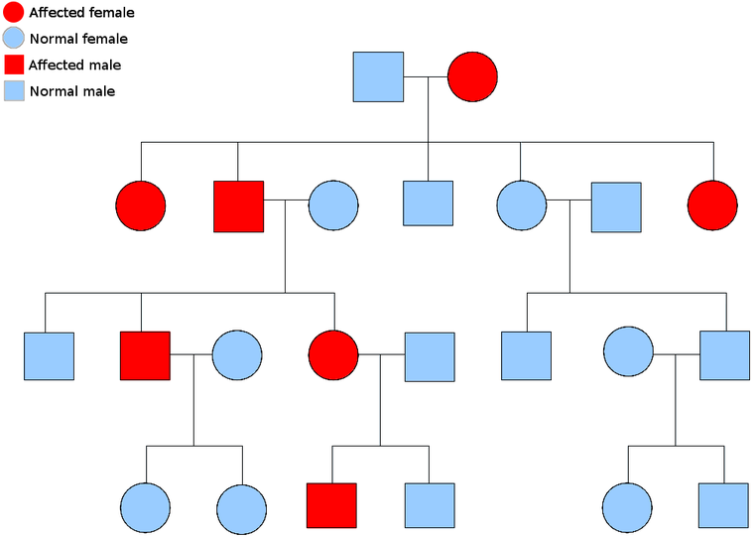

I
II
III
IV
1
2
2
1
2
1
2
1
4
3
5
6
7
4
3
5
6
7
8
4
3
5
6
"Autosomal dominant.png” by Simon Caulton, used under CC BY-SA 3.0. In grayscale with numbers and boxes added.

B. Autosomal recessive pedigree
The chart in Figure 10below represents autosomal recessive mutations. Both parents are heterozygous (Bb). Punnett square results suggest the following genotypes: 25% BB; 50% (Bb) and 25% (bb).
Remember: the Punnett square results tell us the probability, NOT the actual mating outcome. Each fertilization between gametes is by chance.
Activity 2: Determine the genotype for each generation and offspring in Figure 10. Enter your answers in the empty boxes.

Figure 10. Autosomal recessive pedigree over four generations
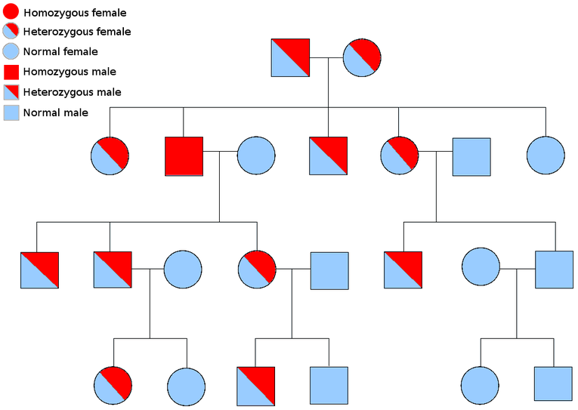

I
II
III
IV
2
1
4
3
5
6
7
2
1
4
3
5
6
7
8
2
1
2
1
4
3
5
6
"Autosomal recessive.png" by Simon Caulton, used under CC BY-SA 3.0. In grayscale with numbers and boxes added.

C. Sex-linked pedigree
Humans have twenty-two pairs of autosomes and one pair of sex chromosomes (X and Y). In the previous pedigree charts, the mutations were on the autosomes. The pedigree chart in Figure 11 below illustrates mutations inherited on the X chromosome. The female parent will always pass the mutation on to her son. The female parent in the chart below has a mutation on her X chromosome. She is considered heterozygous because the other X chromosome is not affected. The mom’s genotype can be written in the following way (X^{H}X^{h}). The dad’s genotype can be written like this: X^{H}Y. Notice the mutated gene (C) is written as a superscript. There will always be a 50% chance of having a male or female child with each fertilization event between ovum and sperm. A Punnett square analysis between gametes of the parents (I-1 and I-2) predict the following genotypes: 25% X^{H}X^{H}; 25% X^{H}X^{h}; 25% X^{H}Y; 25% X^{h}Y.
Activity 3: Determine the genotype for each generation and offspring in Figure 11. Enter your answers in the empty boxes.

Figure 11. Sex-linked pedigree over four generations
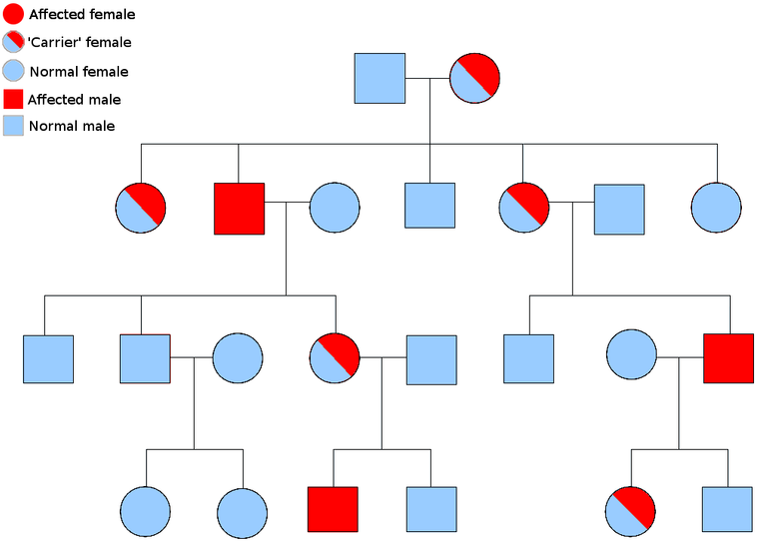
2
1
4
3
5
6
I
II
III
IV

2
1
4
3
5
6
7
2
1
2
1
4
3
5
6
7
8
"Sex linked inheritance.png" by Simon Caulton, used under CC BY-SA 3.0.
In grayscale with numbers and boxes added.

First and last name:
Enter your first and last name (required).

Copyright and attribution
Exercise 1 activity is from "Meiosis Introductory Activity". Wohlwill, Arthur, CC-BY-NC-SA. Exercise 2 Fertilization, activities A to F are adapted these two documents on Mitosis and Meiosis: (1) Meiosis and Fertilization – Understanding How Genes Are Inherited and (2) Mitosis – How Each New Cell Gets a Complete Set of Genes, by Drs. Ingrid Waldron, Jennifer Doherty, Scott Poethig and Lori Spindler, Department of Biology, University of Pennsylvania. CC-BY-NC 4.0. Figures 1 to 6 and Table 1 within Exercise 2 are adapted from the images in these documents. The idea for Exercise 3 Punnett square and BabyMaker reference sheet come from "Making Babies with Punnett Squares" (copyrighted 2017), by Eli Sheldon, licensed under the Creative Commons Attribution Non-Commercial Share Alike license.
This derivative work is licensed under a Creative Commons Attribution 4 International.

