Lab 12: Ecology

Overview
This lab will give the student brief explanations of the basic principles of ecology and our ecosystem. The student will be able to explore the components of ecosystems through these laboratory activities.

Learning objectives
- Be able to define ecology, population, community, and ecosystem
- Be able to differentiate between producer, consumer, herbivore, carnivore, omnivore, parasite, decomposer, and detritivore
- Be able to assign organisms to their trophic level and construct a food web

Materials and equipment
- Scissors
- Glue
- Paper
- Jenga game
- Colored markers

Background
Vocabulary
- Consumer a living organism that eats plants or other animals
- Decomposer an organism that breaks down dead plants and animals, returning nutrients to the soil
- Energy allows an organism to move and do work from food that is eaten
- Food chain the order of eating, or energy transfer, in an ecosystem
- Food web the interaction of all related food chains
- Plankton microscopic organisms floating in water
- Producer a plant or plankton that changes the sun’s energy into food
Ecology is the study of the relationships between living organisms, including humans, and their physical environment; it seeks to understand the vital connections between plants and animals and the world around them. Ecology also provides information about the benefits of ecosystems and how we can use earth’s resources in ways that leave the environment healthy for future generations. An ecologist studies the relationship between living things and their habitats. In order to learn about the natural world, ecologists must study multiple aspects of life ranging from the moss that grows on rocks to the wolf population in Yellowstone National Park.
A food chain is web of organisms that eat one another so that energy and nutrients flow from one to the next. For example, if you had a cheeseburger for lunch, you might be part of a food chain that looks like: Alfalfa (hay) → cow → human. If you had a slice of tomato on your cheeseburger then your food chain looks like tomato → human. However, food chains Figure 1 are not as simple as such because we cannot always fully describe what each organism eats in one straight path. Therefore we use food webs Figure 2 which represents many intersecting food webs indicating what each organism consumes.
Figure 1. Food chain with producer and consumers

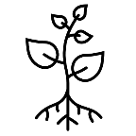Plants 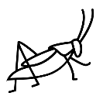InsectsFrog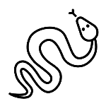Snake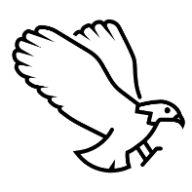Eagle

Figure 2. Food web showing multiple feeding relationships but not clear trophic levels

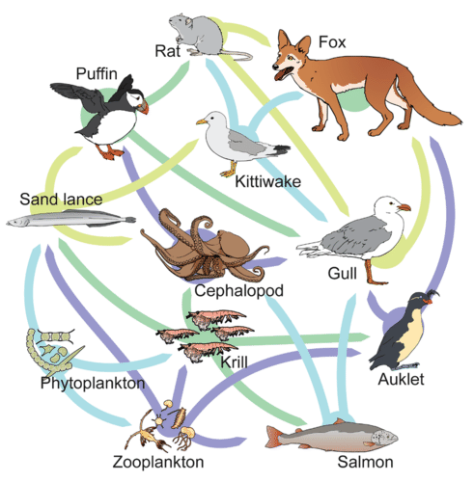
Examples of food webs, by Mariana Ruiz Villarreal (LadyofHats) for CK-12 Foundation, is licensed under CC BY-NC 3.0.
Table 1. Different trophic levels of the energy pyramid
Trophic Level | Types of Organisms | Where It Gets Food | Example
1st Trophic Level: Primary Producer | Photosynthetic Autotrophs | Makes its own food | Plants make their own food
2nd Trophic Level: Primary Consumer | Herbivores | Consumes primary producers | Mice eat plant seeds
3rd Trophic Level: Secondary Consumer | Primary carnivores | Consumes primary consumers | Snakes eat mice
4th Trophic Level: Tertiary Consumer | Secondary carnivores | Consumes secondary consumers | Hawks eat snakes

Figure 3 is an ecological pyramid illustrating the large amount of phytoplankton needed to support the carnivores of the oceans. This energy pyramid has four trophic levels, which signify the organisms place in the food chain from the original source of energy.
Figure 3. Ecological pyramid with four trophic levels
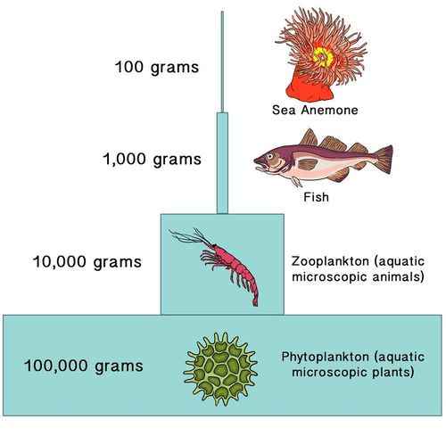
Figure 4 shows different populations together make up a community. Communities together with the non-living things in their surroundings make up an ecosystem. All the ecosystems on Earth make up the biosphere
Figure 4. Flow chart of different communities within an ecosystem
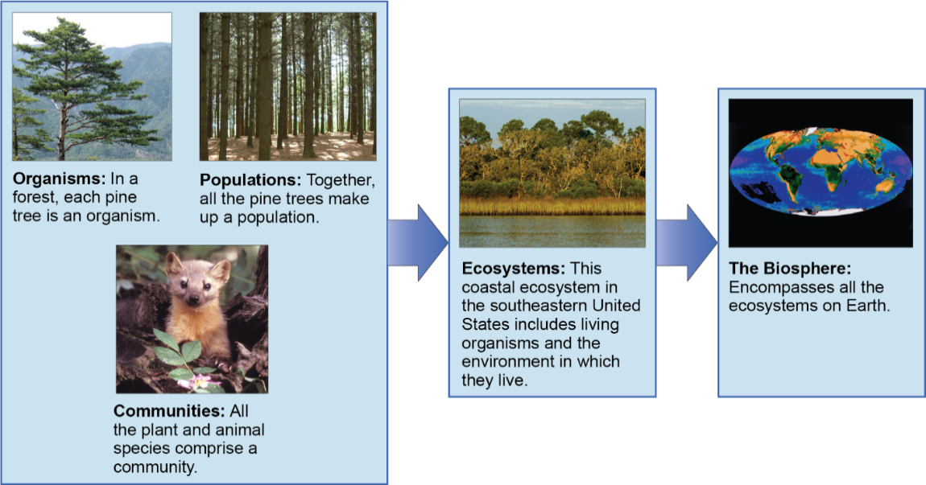

Procedures Part I Biome Ecosystem
Figure 5. Microorganisms and climate change in marine and terrestrial biomes
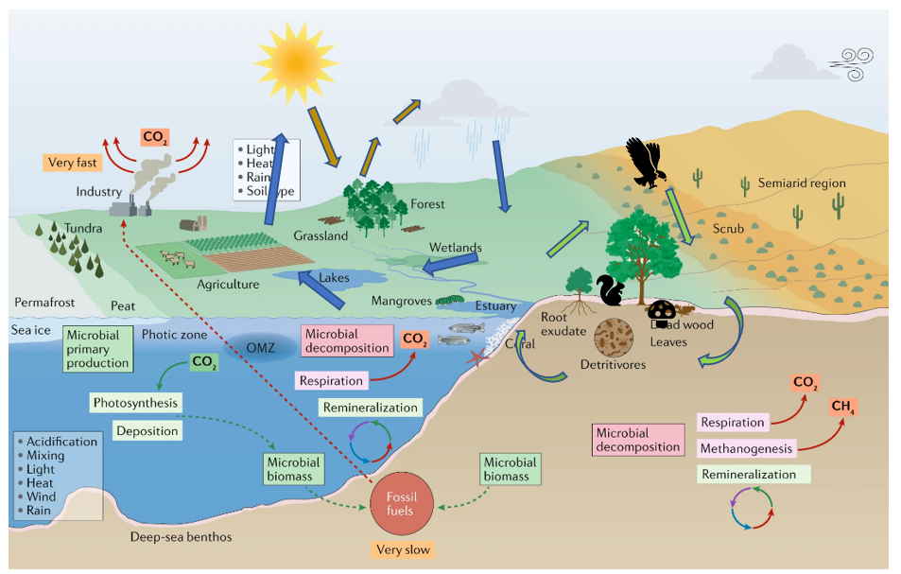Microorganisms and climate change, used under CC-BY-4.0. Black icons and additional arrows added.

Questions
Before going on to the next section, answer the following questions.
- List some of the abiotic things in the ecosystem shown in Figure 5.
Click or tap here to enter text.

- For each of the organisms, discuss how you think the organisms below are interacting with the abiotic environment.
a.The eagle b.The trees and grass c.The mouse d.The worm and insect
Click or tap here to enter text.
- In Figure 5, the blue arrows show the movement of water through the ecosystem. What do we call this movement of water?
Click or tap here to enter text.

- Temperature is an abiotic factor in an ecosystem. What can affect the temperature in the ecosystem?
Click or tap here to enter text.
- Another abiotic factor which affects ecosystems is the slope of the land. For example, is it flat or are there hills or mountains. How would you describe the land in the grassland ecosystem? How do you think this contour affects the ecosystem?
Click or tap here to enter text.
Watch the following YouTube Videos
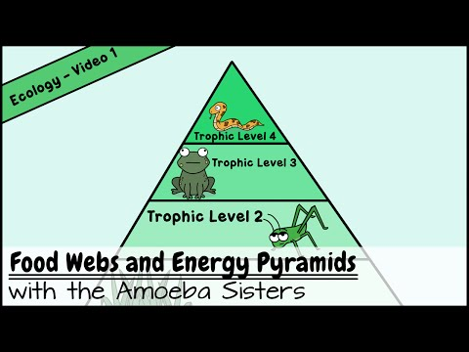
Amoeba Sisters. (2015, July 24). Food Webs and Energy Pyramids: Bedrocks of Biodiversity [Video]. YouTube. https://youtu.be/-oVavgmveyY
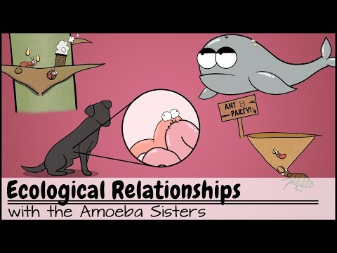
Amoeba Sisters. (2017, November 27). Ecological Relationships [Video]. YouTube. https://youtu.be/rNjPI84sApQ

Procedures Part II Ecosystem Jenga
Instructions (PDF file)
Virtual Jenga
Figure 6. Stack of Jenga blocks
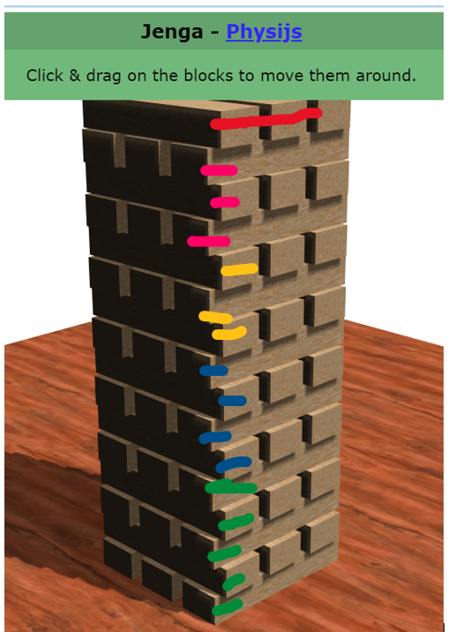
(https://chandlerprall.github.io/Physijs/examples/jenga.html)
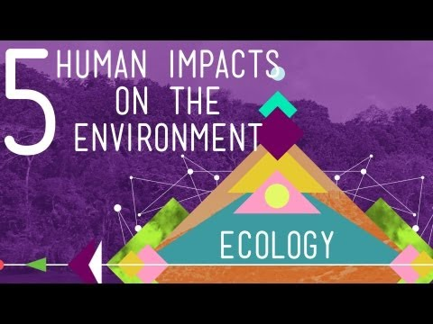
CrashCourse. (2013, Jan 10). 5 Human Impacts on the Environment: Crash Course Ecology #10 [Video]. YouTube. https://youtu.be/5eTCZ9L834s

Procedures Part III Food Web and Energy pyramid
Let us test our knowledge of the food web and the energy pyramids.
Table 2. Instructions for making a food web and energy pyramid
Steps | Figures
Use any square piece of paper.  If it does not have equal sides, bring the short side over the long side and fold. | 7a.
When the triangle is formed, cut out the piece that is extra. | 7b.
Fold the square again in the opposite direction. You will have shape of X on the square.  Cut one of the corners and stop at the middle. | 7c. 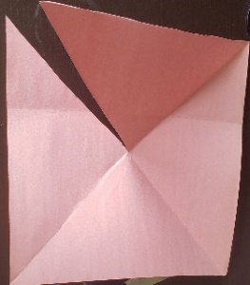
You will have a pyramid that looks like Figure 7d.  Before you glue or tape, draw three lines for each trophic level | 7d. 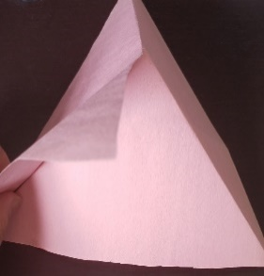
You need to design your own energy pyramid. Decide on the organisms that will go into each level.  You will need producers, primary consumers, secondary consumers and a tertiary consumers. Figure 8 is an example. You have to come up with a different one. | 7e. 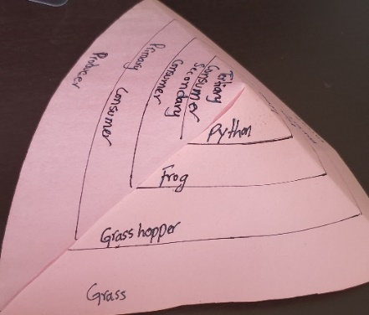
Figure 8. Square paper with producer and consumers labeled by trophic levels
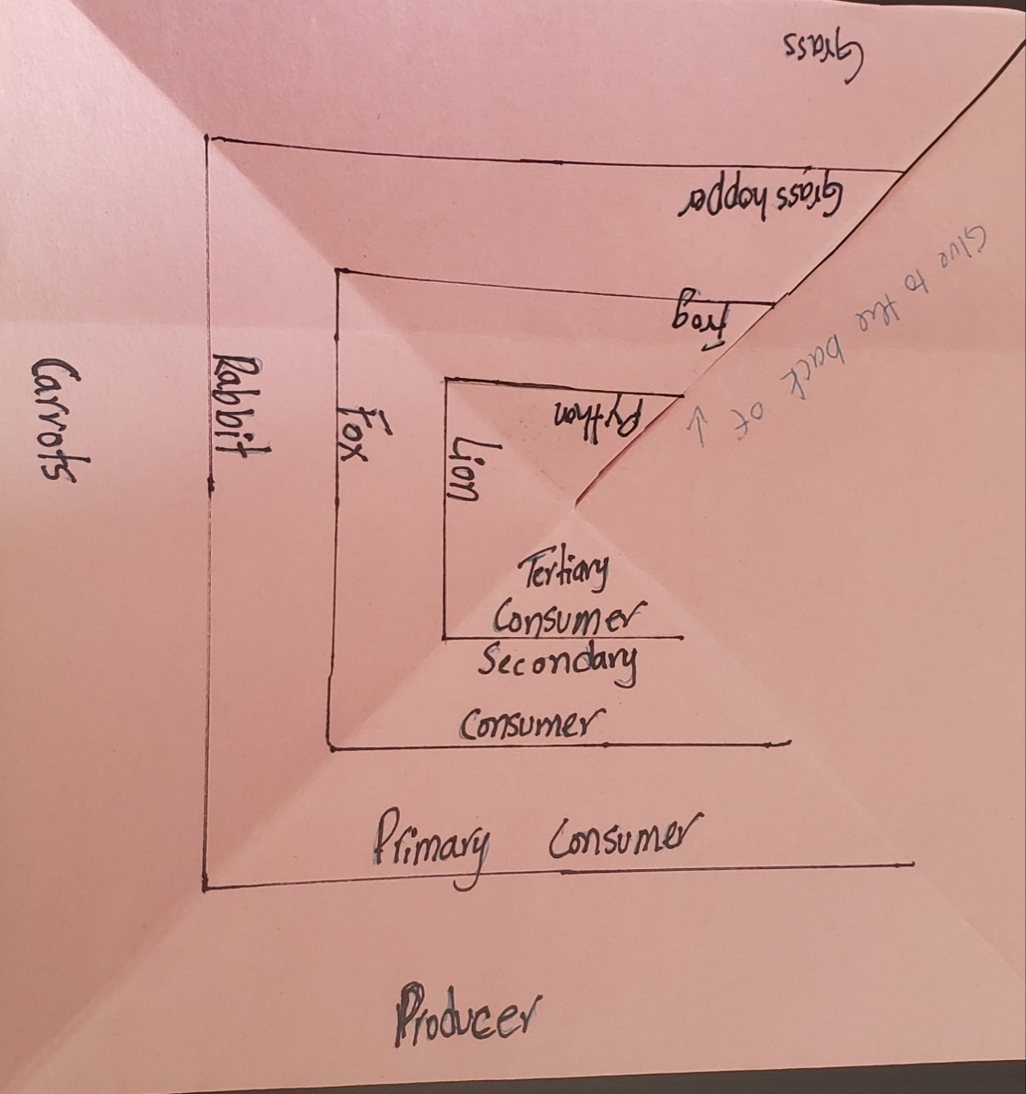

Table 3. Food webs
Organism | Food Source(s) | Trophic Level
Bacillus | Dead vertebrates | Enter text
Blackberry bush | Sun | Enter text
Bumblebee | Plant juices | Enter text
California gopher snake | Small rodents | Enter text
California tiger salamander | Insects | Enter text
California tree frog | Insects | Enter text
Desert tortoise | Leaves, flowers, fruit | Enter text
Duckweed | Sun | Enter text
Fairy shrimp | Algae, bacteria, protozoa, detritus | Enter text
Fly | Nectar | Enter text
Fresno kangaroo rat | Seeds, grasses, some insects | Enter text
Golden trout | Insect larvae, aquatic nematodes | Enter text
Grasshopper | Grasses | Enter text
Mosquito | Blood of mammals | Enter text
Mountain lion | Deer | Enter text
Mushroom | Decaying plants | Enter text
Opalinida (a protozoan) | Lives in the intestines of fish, amphibians, and reptiles | Enter text
Saprolegnia (pond mold) | Dead fish | Enter text
Screech owl | Rodents, fish, amphibians | Enter text
Sierra Nevada bighorn sheep | Grasses, woody plants | Enter text
Tule elk | Acorns, twigs, shrubs, berries, grasses, herbs | Enter text
Valley oak tree | Sun | Enter text
Water strider | Insect larvae, especially mosquito larvae | Enter text

Questions
- What is an herbivore? Write a definition below and then give four examples of animals from that are herbivores.
Click or tap here to enter text.
- What is a carnivore? Write a definition below and then give four examples of animals that are carnivores.
Click or tap here to enter text.
- There are different types of carnivores. Some carnivores hunt other animals. They are called predators. The animals that they hunt are called prey. A lion is an example of a predator. Give three examples of animals which are prey of a lion.
Click or tap here to enter text.
- Other types of carnivores are called scavengers as they eat dead meat, for example a hyena. There are other scavengers. Identify them!
Click or tap here to enter text.
- What do we call animals that eat both plants and other animals? Give one example.
Click or tap here to enter text.
- What would you classify humans as?
Click or tap here to enter text.
- The last group of organisms are the decomposers. Decomposers break down the remains of dead plants and animals. Give an example.
Click or tap here to enter text.
Refer to the study of an ecosystem in or near your school that you are busy with.
- List the producers in your ecosystem. Explain how you know they are producers.
Click or tap here to enter text.
- List the herbivores that you found in your ecosystem. Explain how you know they are herbivores.
Click or tap here to enter text.
- Did you find evidence of or find examples of carnivores in your ecosystem?
List them below.
Click or tap here to enter text.

First and last name:

Enter your first and last name (required).
Follow your instructor's directions in renaming and submitting your lab.

Copyright and attribution
This work is licensed under a Creative Commons Attribution 4 International.

