Lab 8. DNA - Isolation, Structure, and Technology

Learning objectives
- To learn how to isolate DNA from plant tissue.
- To understand the structure of DNA.
- To comprehend the rules of base pairing.
- To explore the process of DNA fingerprinting.
- To construct a DNA molecule from its building blocks.
- To be able to simulate DNA fingerprinting using paper diagrams.

Materials and equipment
- 100-mL beakers
- Cheesecloth
- Large test tubes
- Hooked pipettes or glass rods
- 70–95% ethanol
- Strawberries, cut into quarters
- Lysis buffer
- Ziplock bag
- DNA puzzle pieces
- Crime Scene sample and suspect
- Samples 1, 2, and 3
- Restriction Enzyme
- Scissors

D. Virtual Lab Activity of human DNA isolation
DNA Extraction
https://learn.genetics.utah.edu/content/labs/extraction

Background
This experiment is a simple, effective protocol for isolating and observing DNA from plant tissue. Strawberries are a good source for extracting DNA because they are soft, making them easy to crush and break open the cell walls, where the DNA is located. Most importantly, strawberries have more DNA than any other fruit (having eight copies of each chromosome), meaning there’s more DNA available to collect.

Procedure

A. Isolation of DNA from plant tissue
- Place 2 to 3 pieces of strawberry into a Ziploc bag.
- Smash the contents of the bag for approximately 2 minutes.
- Add 10 ml of lysis buffer to the bag and resume smashing the Ziploc bag for another 2 minutes.
- Open the Ziploc bag and filter the strawberry mixture through several pieces of cheese cloth into a beaker. Pour another 5ml of lysis buffer through the cheese cloth filter. Squeeze the cheese cloth to get as much liquid as you can, leaving the solids behind.
- Fill a test tube with the liquid strawberry extract until the test tube is about 1/3 full.
- Tilt the test tube and slowly pour cold 70 to 95% ethanol down the side of the tube so it forms a layer on top of the DNA mixture. Keep pouring until you have the same volume of alcohol as DNA mixture (see Figure 1). Do not mix or stir.
- After a few minutes, watch for a white layer to form above the strawberry extract layer. Congratulations! This is your DNA!
- Use a pair of tweezers or glass rod to collect or spool the DNA (see Figure 2).

Figure 1: DNA Extraction of Wheat Germ
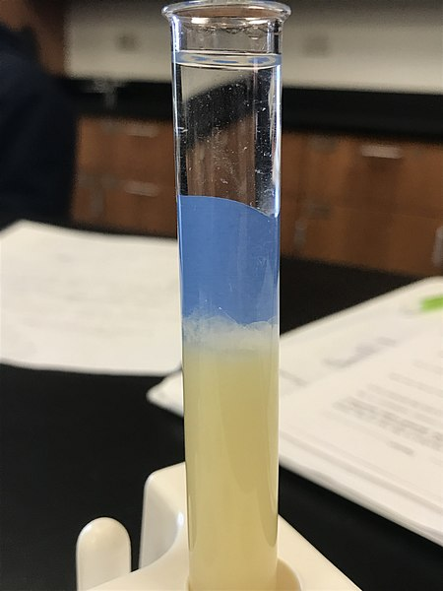
DNA Extraction of Wheat Germ, byJlipuma1, is licensed under CC-BY-4.0

Figure 2: DNA Isolation
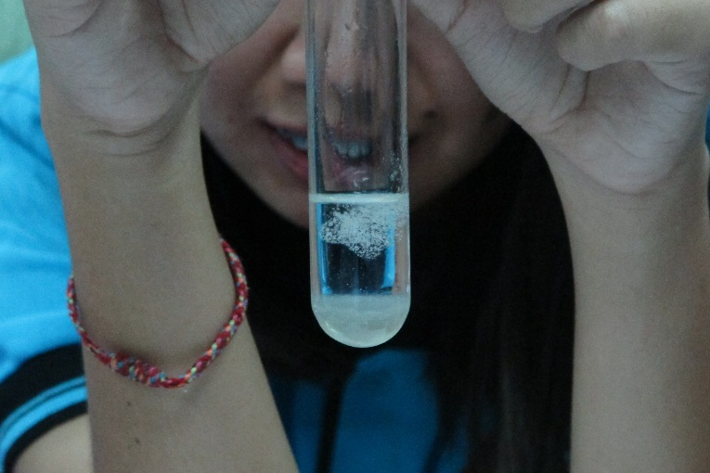
DNA Extraction, by Joo Nath, is licensed under CC-BY-4.0

B. DNA Structure and Replication
Paper DNA Model: Part 1: Preparing the Nucleotides (HHMI BioInteractive Video)
https://edpuzzle.com/media/5f92fcc5c30e46408d1e2775
Paper DNA Model: Part 2: Folding the Nucleotides (HHMI BioInteractive Video)
https://edpuzzle.com/media/5e913d88296ddc3f30fb8ede

Predict
Looking at the structure of the four types of base pieces, predict which ones will pair together to form the double helix “rungs” of DNA. Record your answer on the data sheet.

Protocol
- Get a puzzle kit and work in pairs to construct and replicate your DNA molecule.
- Leave the remaining pieces in the box and set it aside.
- To construct a DNA nucleotide (the building block), you will need to join:
- Adeoxyribose sugar (dark pink)
- A phosphate (yellow); and
- Any one of the four bases (adenine, thymine, guanine or cytosine).
- You will need to assemble five more nucleotides, using the rest of the sugar & phosphate pieces and the remaining bases (A, T, G, and C) of your choice.
- You can now attach these six nucleotides together. This construction represents one strand of the DNA “ladder.” Your strand should resemble Figure 3.
- Using the remaining eighteen puzzle pieces, assemble the other six DNA nucleotides, each with the remaining bases. Do not link these together yet but leave them as individual nucleotides
- The notches and projections in the bases of your free nucleotides, represent the hydrogen bonding sites at the dotted lines where the bases fit together (base pairing).
- There are bases that can only fit with certain other pieces. Look at the strand that you designed and examine which bases will bond with one another and the number of hydrogen bonds between the bases.
- Once you see which base complements the other, align these bases along the DNA strand you had designed constructed in step five. This is you double-stranded DNA structure and should resemble Figure 4.
- DNA replication model:
- Construct twelve more DNA nucleotides, with the remaining nitrogen bases. Do not link them into strands.
- Using the double-stranded DNA segment you constructed in step nine, separate the two strands approximately 25 cm apart.
- Link the complementary nucleotides you constructed to each of the “old” strands, joining them at their sugar/phosphate pieces.
- When you are finished, you should have TWO double-stranded segments of identical DNA. If you are done, return your puzzle pieces to the correct box with the number corresponding to the numbers on the back of your pieces.

Figure 3: Single Strand of DNA
DNA Replication, by Eunice Laurent, is licensed under CC-BY-NC-SA-4.0
Figure 4: Double Strand of DNA
DNA Replication, by Eunice Laurent, is licensed under CC-BY-NC-SA-4.0

Figure 5: DNA replication
DNA Replication, by Eunice Laurent, is licensed under CC-BY-NC-SA-4.0

C. DNA Fingerprinting Simulation
Virtual Lab Activity: Create a DNA Fingerprint
https://stories.wgbh.org/create-dna-fingerprint/
- Each group will be assigned to process either the crime scene DNA (red sheet) or one of the three suspects DNA (blue, yellow or green sheet). You will work in groups of three, thereby processing a replicate of each DNA sample.
- Cut out all six strips from your assigned sheet and tape them into one long strip with the bottom of #1 attached to the top of #2, bottom of #2 attached to top of #3, etc.
- With the restriction enzyme card, move along the base pair sequence of the DNA and mark any matches found.
- Cut the DNA at the places you’ve marked.
- Separate the fragments of DNA according to size; place the largest ones furthest away from you and the smallest closest to you. This represents the separation that occurs during gel electrophoresis, in which the smallest, lightest samples move the fastest in the gel. (Figure 6)
- Count the base pairs in each fragment of DNA.
- On the Gel Lane Sheet, mark bands on the lane labeled for your sample. These bands will correspond to the number of base pairs in each DNA fragment. For example, if you have five fragments of crime scene DNA that are 22, 15, 12, 8, 3 base pairs long respectively, you should draw heavy bands at those numbers in that order on the “Crime Scene” lane. If you have more than one fragment of a given size, make the band darker on the gel lane sheet.
- Compare your results with the other group at your group. If they agree, mark your bands on the Gel Lane Sheet spreadsheet on the computer at the front of the lab.
- Compare the results from the crime scene DNA to each suspects DNA, to determine the identity of the crime scene DNA.

Figure 6: Hand-drawn Gel Electrophoresis Sketch
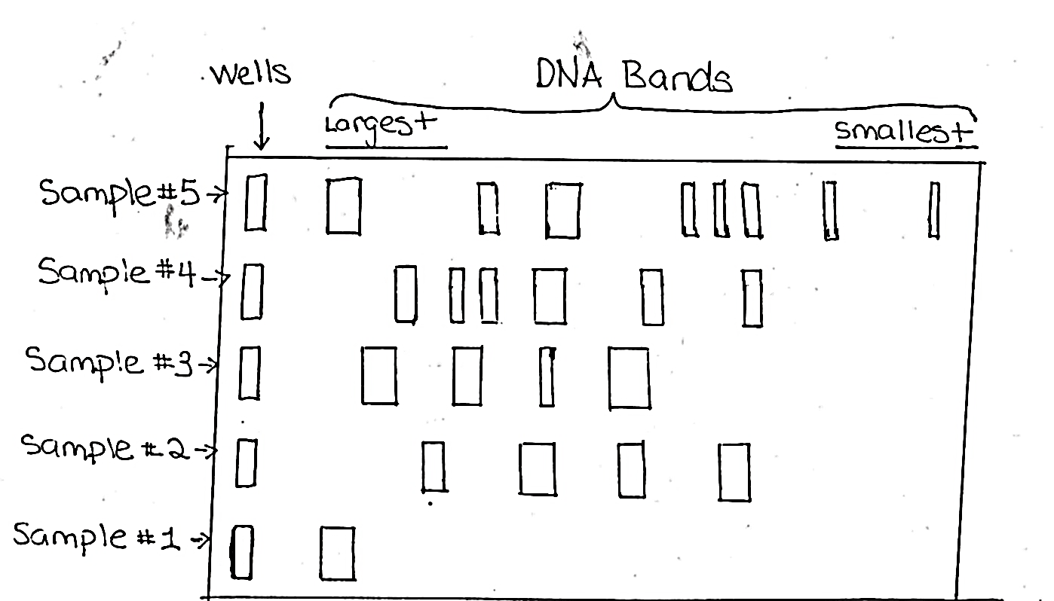
Please attach an image of your results.

Strawberry DNA Results

First and last name:
Enter your first and last name (required).
Follow your instructor's directions in renaming and submitting your lab.

Copyright and attribution
This work is licensed under a Creative Commons Attribution 4 International. It was previously published as “Water in your neighbourhood: a model for implementing a semester-long course-based undergraduate research project in introductory biology,” in Education Inquiry, (2020) DOI:10.1080/20004508.2020.1716542 as an Open Access article with the Creative Commons Attribution-NonCommercial License. All figures have been modified.

