# Lab 2. Microscopy

## Overview

This lab will give the student brief explanations of the basic principles by which microscopes work as well as some hands-on experience with the use of the compound microscope, preparation and staining of wet mounts and measurements of microscopic structures. Students will learn units and conversions using the metric system.

## Learning objectives

1. Have a basic understanding of the use of a microscope.
2. Be familiar with the properties of light that are important in understanding how microscopes work.
3. Be familiar with the markings on the individual objective lenses and their meanings.
4. Be able to prepare wet mounts of both plant and animal cells.
5. Be familiar with the use of stains to improve contrast.
6. Be familiar with the methods for determining field diameter, object size, drawing and photo magnification.
7. Be familiar with the meaning of the resolving power of a microscope and its relationship to magnification.

## Materials and equipment

* Compound microscope
* Unit conversion table (in manual) Plastic (clear) ruler
* Stage Micrometer slide
* Plain slides
* Coverslips
* Ocular micrometer
* Toothpicks or cotton swabs
* Methylene blue stain
* Fresh white onions
* Lugol’s stain
* Lens cleaning solution

## Background

The microscope is an indispensable tool in the study of cells. Anton van Leeuwenhoek (1632-1723) first observed protozoans using simple microscopes with a single lens to magnify the image. Today, compound microscopes have a two-lens system that achieves much greater magnification with greater resolution.

The objective of this lab is for you to become familiar with the use of compound microscope and to review its parts while learning slide preparation techniques, measuring techniques, and observing different types of cells.

The compound microscope you will be using in this lab is shown in Figure 1. Before you begin working with the microscope, you should be familiar with all its parts.

1. The **illuminator** is built into the base of the microscope and the light that is produced here comes from a high intensity bulb. The size of the illuminated field produced can be regulated by the **field diaphragm**. Each objective lens will require different sizes of illuminated fields to work optimally.
2. Light then passes to the **condenser**, which consists of an adjustable system of lenses that focus the light on the specimen. The **condenser/iris diaphragm** controls the diameter of the light beam entering the condenser. Both the **field** **diaphragm** and the **iris diaphragm** must be centered and adjusted in order to get the optimum illumination that will allow the best resolution for each objective lens and the ocular lenses. When light is not centered, there will be scattering.
3. The **objective lens** produces an enlarged and inverted projection of the object, while the **ocular lenses** produce the final image that is further enlarged and still inverted.

Figure 1. Binocular compound microscope with parts labeled

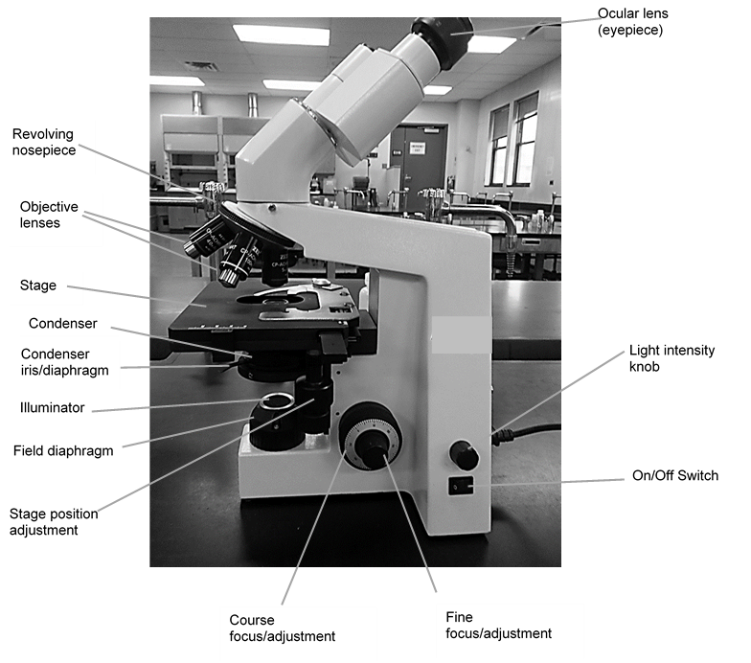

### Magnification and resolving power

* Microscopes vary in magnification and resolving power.
* Magnification is the ratio of an object’s image to its real size.
* Resolving power is a measure of image clarity.

Figure 2. Difference between magnification and resolving power

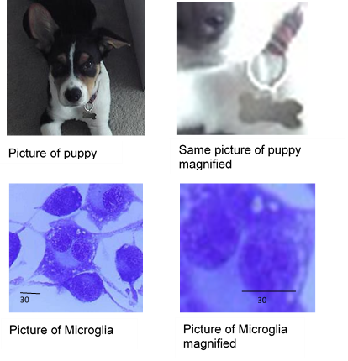

Images can be magnified but that does not increase the level of detail that can be observed, as can be seen in the pictures in Figure 2, where the magnified images appear fuzzy.

* Detail observed when looking under a microscope depends on the resolving power of a microscope.
* The limit of resolution is the minimum distance two points can be separated and still viewed as two separate points.

For our eyes, two points that are closer than 0.19 mm, look like a single point:

Two points that are 0.09 mm apart, we see as a single point  
  
Two dots looking as oneTwo points that are 0.3 mm apart, we see as two separate points  
  
Two separate dots

For microscopes, the resolving power is limited by the medium through which light travels (air or oil) and the quality of the lenses.

Lenses in microscopes are **converging** lenses (thicker in the middle). Lenses cause the light to **refract** (bend); since converging lenses are curved on both sides, the light rays converge at one point, the focal point.

It is very important to have all the lenses aligned, and that the rays of light are falling on the lenses instead of scattering, like illustrated in Figure 3.

Figure 3. Path of light through the converging lenses in a microscope

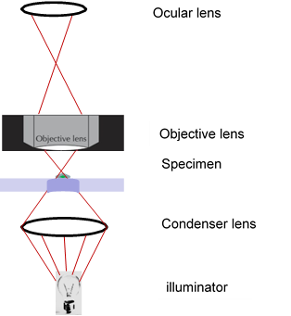

For a good explanation of how converging lenses work, watch [Converging Lenses](https://www.youtube.com/watch?v=R-uMcngNsSk) (https://www.youtube.com/watch?v=R-uMcngNsSk)

### Questions

Before going on to the next section, answer the following questions.

Have your instructor review your answers.

1. In your own words, explain what is meant by the resolving power of a lens.

| Click or tap here to enter text. |
| --- |

1. How does the resolving power of the 10 X objective compare to the resolving power of the 40 X objective?

| Click or tap here to enter text. |
| --- |

1. Draw a diagram of light rays going from a source and through a converging (convex) lens. Label the focal point and briefly describe what happens to light as it goes through the lens.

| To draw with pen/mouse, click here and press enter. Within the ribbon menu, click Insert and select Shapes and the Scribble line. Use callouts to make labels. Other options: copy and paste, upload or attach your drawing or contact instructor for a non-drawing option. |
| --- |

## Procedures Part I

Follow the instructions below and during the experiment record your data in the tables and space given to you for this purpose. Write all the information during the lab.

The following are the different sections you will be completing during the first period of this lab session (approx. 1 hour):

1. Familiarization with the Microscope Components.
2. Measurement of field diameter for 10X and 40X objective lenses
3. Calibration of the ocular micrometer.

### Familiarization with Microscope Components

* Familiarize yourself with your microscope by identifying the components labeled in Figure 1.
* Note the magnification of each objective and the ocular on your microscope and compute the total magnification with each objective and enter the values in Table 1.

Table 1. Magnification

| **Objectives** | **Ocular lens** | **Total magnification** |
| --- | --- | --- |
| 10X low power | Click/tap to enter | Click/tap to enter |
| 40X high dry | Click/tap to enter | Click/tap to enter |
| 100X oil-immersion | Click/tap to enter | Click/tap to enter |

### Measurements

#### A. Determine the field diameter of your field of view: use metric system

To estimate the size of the structures you will be viewing, you can measure the diameter of your field of view for the 10X lens using a transparent ruler.

**You must use the metric system. You will be expected to know all the conversion factors in the metric system**.

Figure 4. Transparent ruler with metric measurement units for length

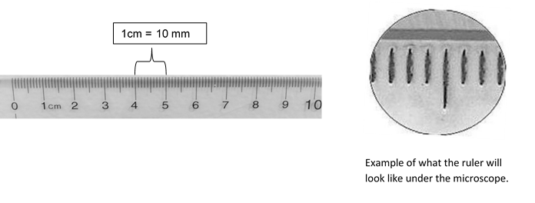Steps:

1. Place a transparent plastic ruler, like the one shown in Figure 4, on the stage and focus, using the 10X objective, on the lines on the ruler.
2. Once you have focused the ruler, count how many divisions can be seen from one edge to the opposite edge (the diameter of the field). Each small division represents 1 mm.  
   How many mm is the field diameter when using the 10X objective? enter mm.
3. Convert the total length of the field diameter from mm into μm. Remember that 1 mm = 1000 μm. enter micrometer.

#### B. Determine the size of cells in a cross section of a stem

Steps:

1. Examine a prepared slide from a cross section of a plant stem. Use your 10X objective.
2. Choose an area of the stem where you can clearly see the cell walls, and which will allow you to count how many cells fill one line across the diameter of your field of view. Choose an area where all cells are roughly the same size.
3. Count how many cells across the field of view.
4. Calculate the average diameter of each cell. To do this, remember that you determined the diameter of your entire field of view, so:

Average size of one cell = total diameter of the field of view (µ𝑚) over total number of cells


Average size of one cell = click/tap to enter number

| Show all your computations below: |
| --- |
| Click or tap here to enter text |

### Calibration of the Ocular Micrometer

A **stage micrometer** is used to calibrate an **ocular micrometer** found in your eye piece.

The ocular micrometer will allow you to measure specimens when using different objectives. The ocular micrometer has no units attached to it and therefore needs to be calibrated, for each objective lens, by its user using the stage micrometer of a known length.

The **stage micrometer** looks like a microscope slide but has a standard scale etched into it. The total length of the scale is usually 1 mm. The **smallest** divisions are 0.01 mm in length (Figure 5).

Figure 5. Diagram of a stage micrometer slide

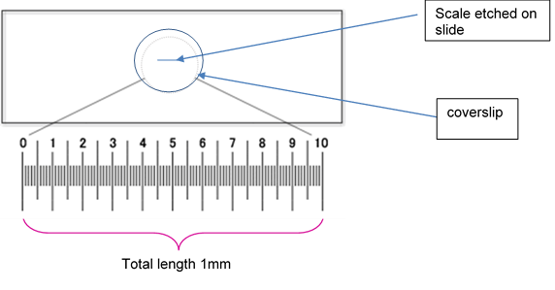

#### To Calibrate the Ocular Micrometer

1. Place the stage micrometer on the stage and using your 10X objective focus on the stage micrometer using the fine adjustment knob.
2. The two scales (ocular and stage) should appear to be superimposed or slightly below one another (Figure 6).
3. Move the stage micrometer to match up the left end of the ocular micrometer with a major marking on the left end of the stage micrometer (Figure 6), if necessary, rotate the eyepiece to line up the micrometers.
4. Scan for a marking on the stage micrometer slide that aligns perfectly with a marking on the ocular micrometer (Figure 7). Measure the distance from zero on the ocular micrometer to the first marking that lines up perfectly on the stage micrometer. See legend in Figure 7 for an example.
5. Use the value you found to calculate the length of one unit (the smallest subdivisions) in your ocular micrometer (see instructions given below). You must repeat this calibration for the 40 X objective.

Figure 6. Alignment of ocular and stage micrometer

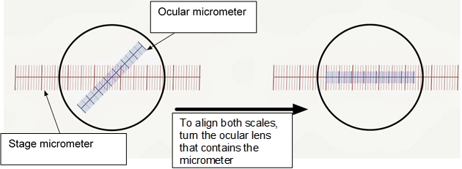

Figure 7 shows the alignment of the ocular and stage micrometers to calibrate the ocular micrometer. The first line in the ocular micrometer is aligned with the 20 marking on the stage micrometer. Scan to the right and you can see that the next marking on the ocular micrometer to align with the stage scale is at 21 subdivisions aligning with 30. This means that 21 subdivisions on the ocular micrometer is equal to 0.1 mm.

Figure 7. Eyepiece and stage micrometer aligned at 21 subdivisions

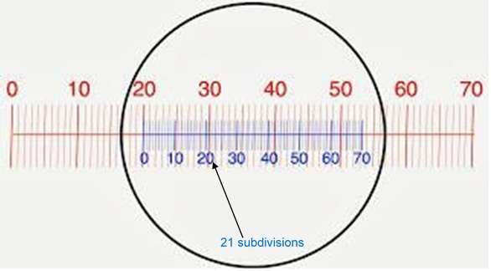

Calculatehow big one **eyepiece division** is.

Example: You know that the total length of your stage micrometer is 1 mm (Figure 2).   
If there are 100 subdivisions in this ruler, then each subdivision on the stage micrometer would be = 0.01 mm.

10 subdivisions in the stage micrometer = 10 X 0.01mm = 0.1mm

so

21 ocular subdivisions = 0.1 mm

1 subdivision = x

so

0.1 mm/21 = x

X = 0.0048 mm or 4.8μm

Enter these values in Table 2.

You will need these values for any future work when you are making measurements of specimens observed under the microscope.

Table 2. Calibration of an ocular micrometer

| **Objectives** | **Total length of scale on ocular micrometer (µm)** | **µm/ smallest division on ocular micrometer** |
| --- | --- | --- |
| 10X low power | Click/tap to enter | Click/tap to enter |
| 40X high dry | Click/tap to enter | Click/tap to enter |

#### Using your ocular micrometer scale to measure your sample:

Once you have gone through all the above steps, you can measure your specimen using the ocular micrometer, and convert the number of eyepiece micrometer divisions you have counted to an actual length (See Figure 8)

For example, in Figure 8, you are looking at a specimen using the 10X objective, and according to your calibration, each subdivision on your ocular micrometer corresponds to 10 μm. To measure the length of a cell, you count the number of subdivisions from one end to the other of the specimen. In this case, 17 subdivisions (from the 30 mark up to the 47 mark). This would mean that the specimen is 17 X 10μm = 170 μm.

Figure 8. Measuring your specimen using your ocular micrometer scale

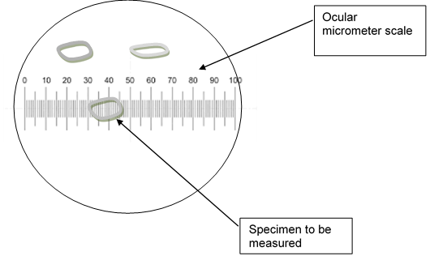

## Procedures Part II

Follow the instructions below and during the experiment and draw what you are observing in the spaces provided. You must record all the information requested in this lab handout. Your instructor will check your drawings and calculations during the lab, Make sure you show your work before leaving the lab.

**Drawing and calculating your drawing magnification**: For each one of these exercises please make sure you complete the following:

* Drawings of what you observe should be done **in pencil.**
* Each drawing should be properly labelled.
* You must record the size of each object you are observing to be able to calculate your drawing magnification.

### Preparation of wet mounts, drawings and calculating magnification

In a wet mount, a piece of tissue is placed on a clean slide with a drop of water, stain or reagent. A coverslip is gently lowered on the preparation. In this lab section, you will be preparing two different wet mounts: onion epidermis and elodea.

#### Onion Epidermis: Observing the structure of plant cells

1. Add a small drop of water to the center of a clean slide.
2. Take a fresh piece of onion and remove a layer.
3. Using forceps strip a small piece of epidermis from the concave surface of a layer and place it on the drop of water, being careful that it does not fold over on itself. Add a drop of water and a coverslip.
4. Use the 5X (scanning) objective to find your specimen and focus using the coarse adjustment. Without touching the adjustment knobs, rotate the revolving nosepiece and place the 10X objective over your slide.
5. Examine the cells with the 10X and the 40X objectives; use the fine adjustment to focus.
6. Slowly close the condenser diaphragm while looking at your slide.
7. What do you observe when you close the condenser diaphragm?
8. How does the opening of the condenser diaphragm affect the contrast?
9. Add one or two drops of Haemalum acid solution at one edge of the coverslip and draw it through by touching a piece of paper towel to the opposite edge of the coverslip. **Wait 10 minutes for the onion skin to stain.**
10. Examine the stained cells with the 10X and 40X objectives, varying the opening of the **iris diaphragm** until the nucleus is clearly visible.
11. Using the ocular micrometer and the 40X objective, measure the length and width of four cells and record it in the table below, use µm (micrometer) as units (use the table where you recorded the calibration for the markings on the ocular micrometer when using the 40X objective).
12. Calculate the average length and width of the onion cells and record it in the table below.

Table 3. Measurements of onion cells

| **Cell** | **Width** | **Length** |
| --- | --- | --- |
| 1 | Click/tap to enter | Click/tap to enter |
| 2 | Click/tap to enter | Click/tap to enter |
| 3 | Click/tap to enter | Click/tap to enter |
| 4 | Click/tap to enter | Click/tap to enter |
| Average | Click/tap to enter | Click/tap to enter |

#### **Onion epidermal cell drawing**

In the space provided below, draw one typical onion epidermal cell and label the visible cell structures. Drawings should be done in pencil and should reflect what you see when looking at the structures under the microscope**.**

Every drawing done should have the following information:

* Name of organism (*Allium cepa* in this case)
* Cell type
* Stain or technique used for the preparation
* Drawing magnification (**size of your drawing of object) / (actual size of object)**

Draw and label one typical onion epidermal cell

| To draw with pen/mouse, click here and press enter. Within the ribbon menu, click Insert and select Shapes and the Scribble line. Use callouts to make labels. Other options: copy and paste, upload or attach your drawing or contact instructor for a non-drawing option. |
| --- |

| Stain: | Click/tap to enter text. |
| --- | --- |
| Actual Size: | Click/tap to enter text. |
| Plate/Drawing Magnification: (size of your drawing of object) / (actual size of the cell) | Click/tap to enter text. |

### Questions

After you finish your drawing, answer the questions below:

1. How does using a stain change the visibility of the structures? Why?

| Click or tap here to enter text. |
| --- |

1. What features can you see under the microscope which allow you to characterize these cells as eukaryotic cells?

| Click or tap here to enter text. |
| --- |

1. Plant cells are surrounded by a plasma membrane and they also have cell walls. What are the major components of plasma membranes? What is the major component of plant cell walls?

| Click or tap here to enter text. |
| --- |

### Cheek epidermal cell: Observing the structure of animal cells

1. Put a drop of methylene blue stain on a slide.
2. Gently (lightly) scrape the inside of your cheek with the flat side of a toothpick.
3. Stir the end of the toothpick in the stain and throw the toothpick away.
4. Place a coverslip onto the slide; if you have excess stain, use a small piece of paper towel to draw the excess stain.
5. Use the 5X (scanning) objective to find the area with cells and focus. You probably will not see the cells at this power.
6. Switch to the low power (10X objective) by turning the revolving nosepiece. You should be able to see the cells although they will appear as small purplish little “clouds”. Any large objects you see are probably crystals from the stain, not cells.
7. Once you think you have located a cell, switch to high power (40X) and refocus using ONLY the fine adjustment.
8. Using your ocular micrometer, measure the diameter of the cells. You will need to record the size of the cells in order to calculate your drawing magnification.

Table 4. Measurements of cheek cells

|  |  |
| --- | --- |
| **Cell** | **Diameter** |
| 1 | Click/tap to enter |
| 2 | Click/tap to enter |
| 3 | Click/tap to enter |
| 4 | Click/tap to enter |
| Average | Click/tap to enter |

In the space below, draw one typical cheek epidermal cell, **labeling the visible cell structures. Drawings should be done in pencil and should reflect what you see when looking at the structures under the microscope**.

Draw one typical cheek epidermal cell

| To draw with pen/mouse, click here and press enter. Within the ribbon menu, click Insert and select Shapes and the Scribble line. Use callouts to make labels. Other options: copy and paste, upload or attach your drawing or contact instructor for a non-drawing option. | |
| --- | --- |
| Stain: | Click/tap to enter text. | |
| Actual Size: | Click/tap to enter text. | |
| Plate/Drawing Magnification: (size of your drawing of object) / (actual size of the cell) | Click/tap to enter text. | |

### Question

What differences could you see, using a microscope, between the onion cells and the cheek cells? Compare structures and size

| Click or tap here to enter text. |
| --- |

## **First and last name:**

Enter your first and last name (required).

## Copyright and attribution

This work is licensed under a [Creative Commons Attribution 4 International](https://creativecommons.org/licenses/by/4.0/). It was previously published as “Water in your neighbourhood: a model for implementing a semester-long course-based undergraduate research project in introductory biology,” in *Education Inquiry*, (2020) [DOI](https://www.tandfonline.com/doi/full/10.1080/20004508.2020.1716542):10.1080/20004508.2020.1716542 as an Open Access article with the [Creative Commons Attribution-NonCommercial License](http://creativecommons.org/licenses/by-nc/4.0/). All figures have been modified.