Lab 3. Organic Molecules - DNA ISOLATION

Overview
During this lab, you will be isolating DNA as one type of organic molecule in the collected water samples. Each step of the isolation process will give you insight into the properties of macromolecules found in living organisms, including lipids, carbohydrates, proteins and nucleic acids. The DNA isolated from the organisms will be sent to be processed for use, in future labs, in the determination of the types and quantities of Bacteria and Archaea found in the water samples.

Learning objectives
- Understand the meaning of water pollution
- Understand the source of organic materials in water.
- Understand the correlation between the number of microorganisms in water and the levels of organic materials in water
- Understand the steps of DNA isolation from water samples.
- Understand how the properties of lipids, polysaccharides and proteins present in cells, are used to eliminate these organic molecules and obtain purified DNA.

Materials and equipment
- Test tubes
- Microcentrifuge tubes
- Pipettes
- Pipettor
- Micropipette tips
- Centrifuge
- Vortex (fitted with tube holder)
- Water sample
- Filter (22 μm or 44 μm mesh) to fit funnel
- Disposable or reusable funnel
- Portable Vacuum
- Small forceps
- Mobio (trademark) Waterpower kit
- Test tube rack
- Water bath 65°C

Background
Deoxyribonucleic acid (DNA) isolation refers to the process of DNA extraction from various sources. Although different methods of DNA isolation are used (depending on the source and sample size), the main steps involved in separating other cellular components from the DNA are similar. In order to obtain good quality DNA required for metagenomic analysis (see explanation below), it is important to process the sample to get rid of all other macromolecules which make up cells. In each step of the process of DNA purification, you will be using different detergents and solvents that allow you to disrupt lipids, proteins, polysaccharides as well as other organic and inorganic molecules that could interfere with the DNA analysis methods.

Microbial metagenomics
The term metagenomics is used to describe the study of the genetic material obtained from environmental samples. Advances in biotechnology, particularly in molecular biology and DNA amplification and sequencing techniques, have allowed for the discovery of microbial diversity in all sorts of environments, which was previously unrecognized. This is due, in part, to the possibility of screening for all different kinds of bacteria using the technique known as Polymerase Chain Reaction (PCR).
Today you will be extracting DNA from organisms present in your water samples. After completing the extraction, the samples will be sent to a lab where the DNA will be amplified in a way that will allow for the identification of all the bacteria found in the sample. In later labs we will be studying the principles and techniques used to increase the number of DNA copies in the sample, as well as the ways in which you can use the information to identify the different bacteria (do the metagenomic analysis) in your sample.

Concepts to understand
Make sure you have a clear understanding of the following concepts after reviewing the provided videos and reading materials:
- Carbon-based molecules:
- Polymer
- Monomer
- Hydrolysis reaction
- Dehydration synthesis reaction
- Monosaccharide
- Polysaccharide
- Triglyceride
- Phospholipids
- Cell membrane
- Hydrophilic
- Hydrophobic
- Protein denaturation
- Protein structures: Primary, secondary, tertiary and quaternary
- DNA
- RNA
- Nucleotide
- Metagenomic

Procedures
Each group will work together to conduct this activity. Every student must record, in their notebook, the results obtained by the group. Your instructor will write her initials once you have completed recording your observations.

Before you begin the purification process
- Examine all the tubes and solutions on your lab bench
- Make sure you have everything you need in your tube rack.
- Label all your empty microcentrifuge tubes (Figure 1) with your group number, using permanent ink.

Figure 1. Microcentrifuge tube
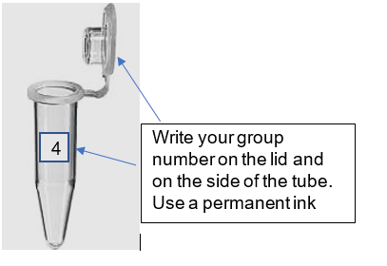

Follow the step-by-step procedure below
This procedure is a modified version of the one provided by the distributors of PowerWater® kit.

Step 1: Filter water samples
- In order to concentrate the material present in your water sample, you will filter 50-100 ml of water using a disposable filter funnel attached to a vacuum source.
- Place filter in funnel or set pre-prepared funnel and filter (Fig 2a) on Erlenmeyer flask as shown in Fig 2b. Once you are sure everything is air-tight, add 50 ml of your water sample to the funnel and open the vacuum. Allow for all the water to be filtered. Repeat the procedure.

Figure 2a. Plastic filter membrane holder
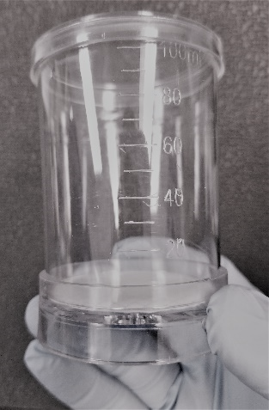

Figure 2b. Filter membrane in disposable filter funnel
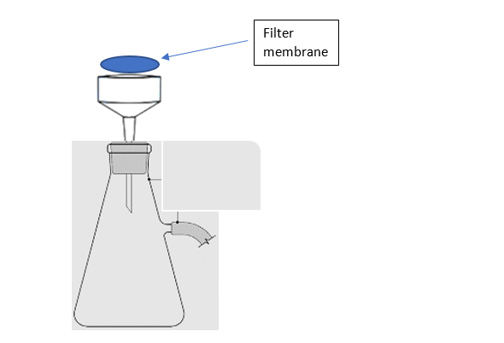

Step 2: Remove filter from funnel and insert the filter into the 5 ml PowerWater® Bead Tube.
- After you have filtered your sample, disassemble the disposable funnel and separate the casing from the filter.
- Carefully pick up the filter using small forceps.
- Roll the membrane around the forceps and insert it into the 5 ml PowerWater® Bead Tube as shown in the Filter Membrane Insertion into Bead Tube video (https://www.youtube.com/watch?v=KUT6nKJPj4s)

Step 3: Add 1 ml of Solution PW1 to the PowerWater® Bead Tube:
Ensure Solution PW1 is well dissolved (no white precipitate visible), otherwise, warm up (in 55º C bath) PW1 for a few minutes until it is completely dissolved and then add 1 ml to the bead tube. PW1 can be used when it is still warm.
What’s happening: Solution PW1 has detergents and reagents that break up cell walls as well as cell membranes and remove non-DNA organic and inorganic molecules.

Step 4: Vortex the bead tubes
- Vortex the bead tubes by securing your bead tube to the adaptor on the vortex (Figure 3).
- Turn on the vortex machine to maximum speed and allow the tubes to mix for 5 min.
What’s happening: The mechanical action of bead beating will break apart the surface of the filter membrane that contains trapped cells and aids in cell lysis.

Figure 3. Vortex with special adaptor holding bead tubes
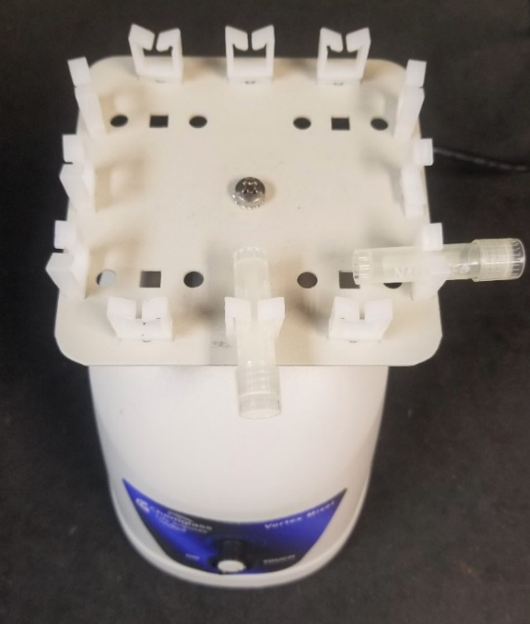

Step 5: Centrifuge the tubes
- Place your tubes in the centrifuge (Fig 4), making sure you balance all the tubes.
- Centrifuge the tubes ≤ 4000 x g for 1 minute at room temperature. If your tubes do not fit in the centrifuge, then transfer all the mixture into a smaller centrifuge tube (don’t leave any liquid behind!).

What’s happening: The debris and beads will precipitate, and the supernatant will contain DNA.

Figure 4. Microcentrifuge with rotor with space for 1.5-2.0 ml microcentrifuge tubes
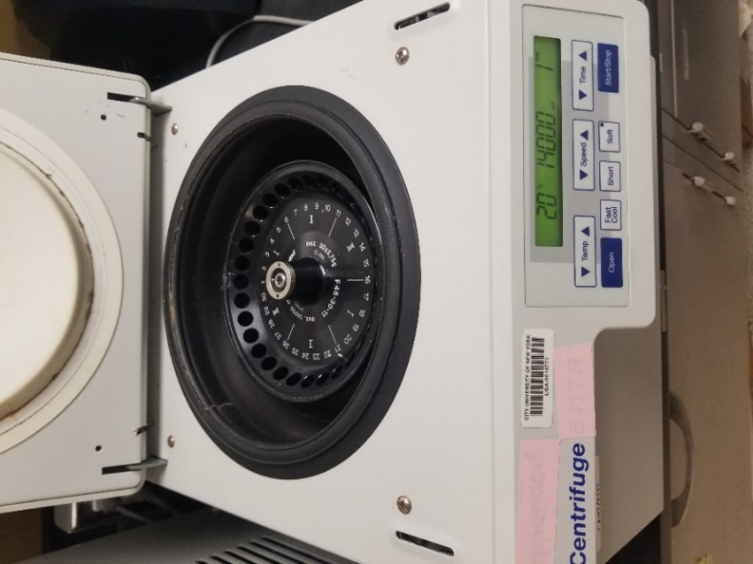

Step 6: Transfer the supernatant (Figure 5) to a clean 2 ml Collection Tube (provided)
- Draw up the supernatant using a 1000 μl pipette tip by placing it down close to the beads.
- Pipette more than once to ensure removal of all supernatant.
Any carryover of beads will not affect the next steps since you will repeat this step as indicated below. Expect to recover between 600-650 µl of supernatant depending on the type of filter membrane used.

Figure 5. Pellet and supernatant after centrifugation
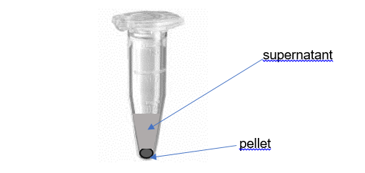
After centrifugation, denser particles will concentrate in a pellet at the bottom of the tube. Other components will remain dissolved in the liquid above the pellet, this liquid is called the supernatant.

Step 7: Centrifuge and transfer to a clean tube
- Centrifuge at 13,000 x g for 1 minute.
- Transfer the supernatant to a clean 2 ml microcentrifuge tube. Make sure you do not disturb the pellet.
What’s happening: Any remaining beads, proteins, and cell debris are removed at this step. This step is important for removal of any remaining contaminating non-DNA organic and inorganic matter that may reduce the DNA purity and inhibit downstream DNA applications.

Step 8: Mix and incubate
- Add 200 µl of Solution PW2 and vortex briefly to mix.
- Incubate at 4°C (place on ice in container provided) for 5 minutes.
What’s happening: Solution PW2 is another part of the patented Inhibitor Removal Technology® (IRT) and is a second reagent to remove additional non-DNA organic and inorganic material including cell debris, and proteins.

Step 9: Centrifuge and transfer to a clean tube
- Centrifuge the tubes at 13,000 x g for 1 minute.
- After centrifuging, carefully transfer the supernatant to a clean, labeled, 2 ml microcentrifuge tube. Make sure not to remove the pellet.
What’s happening: The pellet at this point contains additional non-DNA organic and inorganic material. For best DNA yields and quality, avoid transferring any of the pellet.

Step 10: Add 650 µl of Solution PW3 and vortex briefly to mix
Note: Check Solution PW3 is completely resuspended (no precipitate should be visible), otherwise, warm until it goes in solution. PW3 can be used while still warm.
What’s happening: Solution PW3 is a high concentration salt solution. Since DNA binds tightly to silica at high salt concentrations, this will allow binding of the DNA, but not non-DNA organic and inorganic material that may still be present at low levels, to the spin silica filter (described below).

Step 11: Centrifuge and place Spin Filter basket into a clean tube
  - Load 650 µl of the mixed solution prepared in step 10 onto a Spin Filter placed in a microcentrifuge tube (Fig 6) and centrifuge at 13,000 x g for 1 minute.

Figure 6. Spin filter in microcentrifuge tube
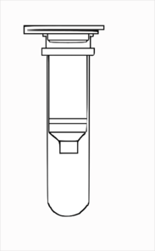
Empty Spin Column, shared by RIE.

After you centrifuge, discard the flow through (filtrate). To discard the filtrate, you will need to carefully take the filter basket out of the tube, then discard the fluid in the tube.
Once you have discarded the filtrate, place the spin filter in the tube once more, then add the rest of the mixed solution prepared in step 10 (don’t add more than 650 µl, if you need to, repeat until all the supernatant has been loaded onto the Spin Filter).
  - Once you have filtered all your solution through the filter, place the Spin Filter basket into a clean 2 ml Collection Tube (provided).
What’s happening: Due to the high concentration of salt in solution PW3, it is important to place the Spin Filter basket into a clean 2 ml Collection Tube to aid in the subsequent wash steps and improve the DNA purity and yield.

Step 12: Add 650 µl of Solution PW4 and centrifuge at 13,000 x g for 1 minute
Note: Shake to mix Solution PW4 before use.
What’s happening: Solution PW4 is an alcohol-based wash solution used to further clean the DNA that is bound to the silica filter membrane in the Spin Filter. This wash solution removes residual salt and other contaminants while allowing the DNA to stay bound to the silica membrane.

Step 13: Discard the flow through, add PW5 and centrifuge
- Discard the flow through by carefully removing the Spin Filter, decanting the filtrate, then placing the Spin filter back into the tube.
- Next, add 650 µl of Solution PW5 and centrifuge at 13,000 x g for 1 minute.
What’s happening: Solution PW5 ensures complete removal of Solution PW4, which will result in higher DNA purity and yield.

Step 14: Discard the flow through and centrifuge again
Discard the flow through and centrifuge again at 13,000 x g for 2 minutes to remove residual wash.
What’s happening: The second spin removes residual Solution PW5 (ethanol). It is critical to remove all traces of wash solution because the ethanol in Solution PW5 can interfere with many downstream DNA applications such as PCR, restriction digests, and gel electrophoresis.

Step 15: Place the Spin Filter basket into a clean 2 ml Collection Tube (provided)

Step 16: Add 100 µl of Solution PW6 to the center of the white filter membrane
What’s happening: Solution PW6 is a sterile elution buffer, by placing it in the center of the small white membrane; you will ensure the entire membrane is wetted. This will result in a more efficient and complete release of the DNA from the silica Spin Filter membrane. As Solution PW6 passes through the silica membrane, the DNA that was bound in the presence of high salt is selectively released by Solution PW6 (10 mM Tris) which lacks salt.

Step 17: Centrifuge and discard Spin Filter basket
- Centrifuge at 13,000 x g for 1 minute. The DNA will now be in the filtrate, do not discard the filtrate.
- Discard the Spin Filter basket. The DNA is now ready for any downstream application.
- Your tubes should be fully labelled. Use the label tape and write the date, group number (include initials of group members).
Your DNA samples will be sent to be processed. A review of the processing (including PCR and metagenomic analysis) will be done later in the semester.

Questions
- a. Where is DNA found in a Eukaryotic cell?
Click/tap here to answer Q.1a.
b. Where is DNA found in a prokaryotic cell?
Click/tap here to answer Q.1b
- To isolate DNA from a cell, which macromolecules need to be eliminated?
Click/tap here to answer Q.2
- What are the components of the cell membrane? Draw a diagram showing the arrangement of these molecules in the cell membrane.
Click/tap here to answer Q.3
- Given the composition of the cell membrane you just described, what methods can be used to lyse (or disrupt) the cell membrane?
Click/tap here to answer Q4
- After the cells are lysed, what procedure can be used to remove the lipids from the rest of the components?
Click/tap here to answer Q5
- Why is using a high concentration of salt important for isolating DNA?
Click/tap here to answer Q.6
- What does ethanol do in the DNA isolation procedure?
Click/tap here to answer Q7
Watch the following videos and read the following article to answer questions 8 and 9
Surface water quality sampling URL: https://www.youtube.com/watch?v=2mx6KHMPfVw
Climate change URL: https://www.youtube.com/watch?v=ifrHogDujXw
Water pollution documentary URL: https://www.youtube.com/watch?v=h198sZXP7fU
Water pollution URL: https://www.youtube.com/watch?v=GNGKsubYJ9U
- What information, in this case regarding your water sample, does a metagenomic analysis provide?
Click/tap here to answer Q.8
- How can we use the result of metagenomic suites to understand climate change?
Click/tap here to answer Q9

First and last name:
Enter your first and last name (required).

Copyright and attribution
This work is licensed under a Creative Commons Attribution 4 International. It was previously published as “Water in your neighbourhood: a model for implementing a semester-long course-based undergraduate research project in introductory biology,” in Education Inquiry, (2020) DOI:10.1080/20004508.2020.1716542 as an Open Access article with the Creative Commons Attribution-NonCommercial License. All figures have been modified.

