Lab 4. Diffusion and Osmosis: Passive movement of molecules in biological systems

Overview
During this lab, you will be determining the salinity of the collected water samples. You will also compare the effect of the solute concentration of your samples with that of solutions of known solute concentrations on plant cells.
Note: You will be incorporating the results obtained during this lab to your final research reports and ppt. presentations.

Learning objectives
- Understand the concept of kinetic energy of molecules and Brownian movement
- Understand the effect of solute concentration and temperature on the diffusion of solutes across a selectively permeable membrane
- Understand the effect of solute concentration on osmosis
- the effect of placing living cells in hypotonic, hypertonic and isotonic solutions
- Determine salinity of water sample
- Understand how to generate a standard curve in order to determine the concentration of an unknown sample

Materials and equipment
- NaCl solutions (0.1M; 0.2M; 0.3M; 0.4M; 0.5M;0.6M) -50 ml each/group
- 8-10 pieces of 15 cm long, 2.5 cm diameter dialysis tubing, pre-soaked in distilled water
- String to tie dialysis tubing
- 8 cups/250 m beakers
- distilled water
- funnel
- Balance
- 25 ml graduated cylinder
- 10 ml pipettes
- Markers
- Microscope
- Ocular micrometer
- Micrometer slide
- Fresh red onions
- Hot plate
- 4 Large watch glasses
- Small spatula
- Weighing boats
- 8 250ml beakers

Background
Before coming to the lab, go over the background Power Point slides and videos posted for this lab. Complete the exercises embedded in the pre-lab homework Power Point and videos and make sure you hand these in to your instructor following the instructions given to you. Make sure you have a clear understanding of the following concepts:
- Concentration of a solute in a solution
- Kinetic energy
- Diffusion
- Osmosis
- Selectively permeable membrane
- Plasma membrane
- Plant vacuoles
- Tonicity: hypertonic, isotonic and hypotonic solutions

Procedures
Every student must do all the calculations, record all the results and draw the graphs during the lab activity. Your instructor will write her/his initials once you have completed recording your results.

Determining the salinity of your water sample by direct measurement of mass after evaporation
Total Dissolved Salts (TDS) is measured by evaporating a known volume of water to dryness, then weighing the solid residue remaining.
Steps:
- Using your balance, weigh a clean, dry watch glass. Record the mass in Table 1.
- Using a 5 or 10 ml pipette, take 10 ml of your water sample and place it in the clean and dry watch glass.
- Carefully place the watch glass on the hot plate and turn the dial to position 2 or 3 (do not heat the plate too much or too quickly).
- Leave the watch glass until all the water has evaporated. (Proceed to the next section of the lab while you wait for the water to evaporate).

Figure 1. Balance used to measure the mass of watch glass with residual salt after evaporation
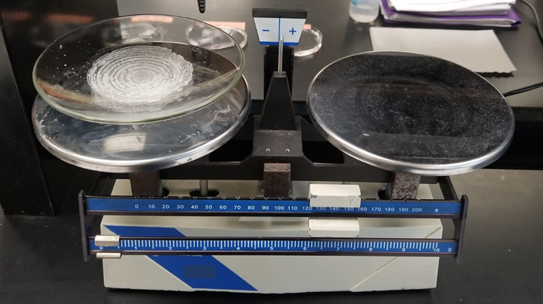
“Balance” by Justin Morales, Laura Pessoa, Jennifer Sanchez and Delilah Ramos is licensed under CC BY 4.0
- Let the watch glass cool; using the balance provided, weigh the watch glass with its contents (Figure 1) and record the value in Table 1.
- Calculate the total mass of dissolved salt in the watch glass by subtracting the mass of the clean watch glass from the mass of the watch glass + salt.
- Record the total dissolved salt by calculating the amount in mg/l. Remember you started with 10 ml of your water sample and the TDS is the amount of salt in 1 liter.

Table 1. Recording of masses to calculate TDS in water sample
Mass watch glass + salt | enter mass
Mass watch glass | enter mass
Mass dissolved salt | enter mass
Total dissolved salt (mg/l) | enter mass

Determining the salinity of your water sample by extrapolation
from a curve made using changes in mass of dialysis bags with known concentrations of NaCl
Note: In this exercise, you will need to prepare six dialysis bags with different solutions of known NaCl concentration, as well as one dialysis bag with your water sample and one with distilled water. Each one of the bags needs to be weighed BEFORE placing it in the beaker with distilled water. Follow the instructions carefully; if you have any questions, ask your instructor.
The solutions have been prepared for you ahead of time; you can fill out the table while you wait for the dialysis.

Table 2. Amounts of NaCl required to prepare 100 ml of six solutions
NaCl concentration | Amount to weigh for 100 ml
0.1 M | 584.4 mg
0.2 M | enter mg
0.3 M | enter mg
0.4 M | enter mg
0.5 M | enter mg
0.6 M | enter mg
Example of how to calculate the amount NaCl needed to prepare solutions of different concentrations:
For NaCl, 1 MV = 58.44 g/l
So, 0.1MV= 5.844g/l; you only want to prepare 100 ml, not 1 l, which is 1,000 ml.
5.844 g = 1000 ml
X = 100 ml
X = 0.5844g
which is = 584.4 mg

Set up for beakers
- Prepare eight 100- or 250-ml beakers; label one as “distilled water”, another as “water sample”, and the rest with each one of the NaCl concentrations shown in Table 2.
- After labelling your beakers, add DISTILLED WATER TO ALL OF THEM, about ¾ full. Set them aside.
- Remove the dialysis bags (provided) from the distilled water and tie off one end using the string or clamp provided.
- To open the other end of the bag (also called tubing), rub it between two fingers. While one person holds the bag, another person can fill it with one solution; if necessary, use a funnel to make sure it does not spill. Do not overfill the tubing. Leave some space for expansion, but no air.
Note
You will need eight dialysis bags; you will fill each bag with one of the NaCl solution (so six bags), one bag with distilled water, and another bag with your sample.

Figure 2. Beakers holding dialysis bags immersed in distilled water
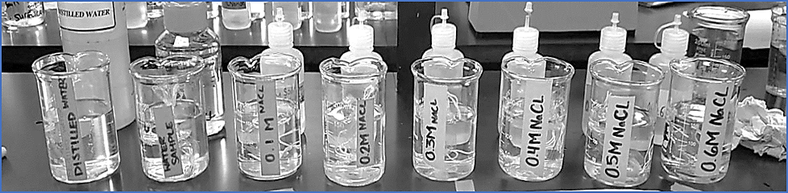
“Beakers” by Veronica Martinez Castro and Elise Oleksiak is licensed under CC BY 4.0
- Tie the other end of the tubing; you can use a clamp, string, or carefully tie the dialysis bag itself. If you are using string, wet the string completely before using.
- Before going on to the next step, dip the filled bags in distilled water, then gently blot each bag dry on paper towel. This will decrease the error in the measurements you will make in step 9.
- While two members of the group continue filling the rest of the tubing, another student should proceed to weigh and record the mass of each one of the filled tubes in the table below.
- Once all eight tubes have been filled and weighed, place them in the distilled water in the labeled beakers as shown in Figure 2. Record the time.
- After 45 minutes, take the bags out of the beakers, gently blot the bags dry, and weigh each one. Record the mass in Table 3.
NOTE: AT THIS POINT, YOU MAY TAKE PICTURES OF YOUR SET-UP IN ORDER TO INCLUDE THEM IN YOUR FINAL PRESENTATION.

Table 3. Recordings of initial masses of dialysis bags at time zero and 45 min after immersion
Bag content | Initial mass | Mass after 45 min | Mass difference | % change in mass
Distilled water | enter mass | enter mass | enter mass | enter mass
Water sample | enter mass | enter mass | enter mass | enter mass
0.1 M NaCl | enter mass | enter mass | enter mass | enter mass
0.2 M NaCl | enter mass | enter mass | enter mass | enter mass
0.3 M NaCl | enter mass | enter mass | enter mass | enter mass
0.4 M NaCl | enter mass | enter mass | enter mass | enter mass
0.5 M NaCl | enter mass | enter mass | enter mass | enter mass
0.6 M NaCl | enter mass | enter mass | enter mass | enter mass
- In the space below (record all your calculations), calculate the % change in mass in the bags, for the different NaCl concentrations.
Example: To calculate the % change in mass, if you have the initial mass, for example 27 g, and a final mass, for example 27.5 g.
- Calculate the mass difference: 27.5 g – 27 g = 0.5 g (record this value in the table above)
- Calculate the % change this difference represents:
27g (initial mass) = 100%
0.5g (mass difference) = X%
0.5g (100%) = 1.85%
27g
YOUR CALCULATIONS: Make sure you record all your calculations!
- Use graph paper provided to graph the % change in mass for the distilled water and the six bags with different known NaCl concentrations. This is your standard curve, which will allow you to find out the salt concentration of your water sample. Why are you asked to calculate the % of change, not just the change in mass?
- Calculate the % change in mass for the bag with the water sample, extrapolate the value on the graph, find the corresponding NaCl concentration and record it:
Salt concentration of water sample based on change in mass and extrapolated from the standard curve you created:
enter mass
- How does the mass of the bags change as the molarity of the solutions in the bags change? Explain why this change occurs:
Click/tap here to answer question.

C. Effect of extracellular solute concentration on vacuoles of plant cells
Note: To complete this section of the lab, you must have calibrated your ocular micrometer on your microscope. Each student must prepare their own wet mount, examine, measure, and record, each one of the preparations.
- Prepare three watch glasses with solutions which are hypotonic (distilled water), hypertonic (20% NaCl), and your water sample. Make sure you label each sample.
- Using tweezers, peel a single layer of the onion, take the colored layer. Place a few strips in each one of the solutions and leave them for a few minutes.
- Make a wet mount, start with the hypotonic solution. Observe under your microscope (follow the guidelines in the lab microscopy unit), and focus under the 10X, then the high dry (40X) objective. Measure the length of at least five vacuoles. The vacuoles are visible, as the purple pigment colors the water inside them.
- Proceed to make wet mounts of the hypertonic solution and make measurements of the length of at least five vacuoles. Finally, do the same for the onion strips in your water sample.
Figures 3a and 3b are examples of epidermal onion cells seen under the microscope after placing onion skins in a hypotonic solution and a hypertonic solution.

Figure 3a. Onion cells in a hypotonic solution
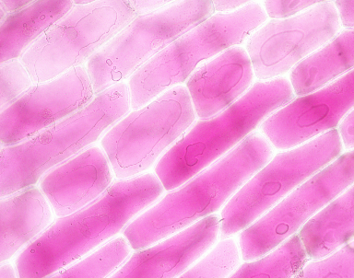

Figure 3b. Onion cells in a hypertonic solution
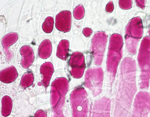
You can take pictures of your cells, as these will allow you to illustrate the results in your assignments and final poster.
- Calculate the average length of the vacuoles for each one of the solutions and record it in Table 4.

Table 4. Length of the vacuoles in μm​
Measurements | Length vacuoles hypotonic solution | Length vacuoles hypertonic solution | Length vacuoles water sample
1 | Enter length | Enter length | Enter length
2 | Enter length | Enter length | Enter length
3 | Enter length | Enter length | Enter length
4 | Enter length | Enter length | Enter length
5 | Enter length | Enter length | Enter length
Average | Average length | Average length | Average length

Questions
Answer each one of the questions in the space provided below
- How does the tonicity of the extracellular fluid affect the size of the vacuoles? What process is illustrated by this effect, explain
Click/tap here to answer question.
- How do the vacuoles of the cells placed in your water sample compare with the vacuoles of cells placed in the hypotonic and hypertonic solutions?
Click/tap here to answer question.
- What prevents the onion cells, which were placed in a hypotonic solution, from bursting?
Click/tap here to answer question.
- Based on your findings, predict possible effects that changes in the salinity of water bodies may have on unicellular organisms.
Click/tap here to answer question.

First and last name:
Enter your first and last name (required).

Copyright and attribution
This work is licensed under a Creative Commons Attribution 4 International. It was previously published as “Water in your neighbourhood: a model for implementing a semester-long course-based undergraduate research project in introductory biology,” in Education Inquiry, (2020) DOI:10.1080/20004508.2020.1716542 as an Open Access article with the Creative Commons Attribution-NonCommercial License. All figures have been modified.

