Lab 6. Cellular Respiration Fermentation

Overview
During this lab you will investigate how glucose concentration affects the rate of fermentation in yeast, a single-celled eukaryote which is capable of alcoholic fermentation. You will also investigate the presence or absence of facultative anaerobic bacteria in your water samples. In particular, you will determine whether your water presents fecal contamination, indicated by the release of acid and gas into the media, due to fermentation. Finally, you will measure the amount of dissolved oxygen in your water samples and determine its quality, by comparing your results with the Environmental Protection Agency (EPA) standards.

Learning objectives
- Describe the process of alcoholic fermentation in yeast and determine the effect of concentration of glucose on the rate of fermentation.
- Understand the differences between anaerobic fermentation and aerobic cell respiration.
- Using your water samples, determine the presence of bacteria that are facultative anaerobes, particularly E. Coli and enterococci bacteria, which ferment sugars producing acid as well as gas.
- Determine the amount of oxygen in your water samples and compare it to the EPA standards for water designated for different uses.

Materials and equipment
- Five 50 ml (milliliter) conical centrifuge tubes
- Five 15 ml conical centrifuge tubes
- 10 ml pipettes
- Clamps for holding conical centrifuge tubes
- Glucose solution 5%
- Glucose solution 7.5%
- Yeast (Saccharomyces cerevisiae) culture
- Test tube rack
- 70% ethanol for disinfecting
- 2 lactose broth test tubes
- Mineral oil
- TSA-agar plates

Background
Most present day unicellular and multicellular organisms have enzymes that allow cells to harvest chemical energy in organic molecules, such as glucose, and use that energy to make ATP (adenosine triphosphate). Heterotrophs, such as animals, need to ingest those organic molecules, while autotrophs, such as plants, are able to harvest the energy from light, in the process of photosynthesis, and “fix” carbon dioxide to synthesize their own organic molecules.
Cellular respiration is a controlled process where the energy of glucose is released in a series of steps, with orderly chemical reactions that allow the high-energy electrons in glucose, to be picked up and used to make ATP. The first step, glycolysis, does not require oxygen to take place; it is an anaerobic process. The resulting molecule, pyruvate, still holds a lot of chemical energy in it. This chemical energy is harvested in two steps, which are oxygen-dependent or aerobic, the citric acid cycle and the electron transport chain and oxidative phosphorylation (Figure 1).
Figure 1. Aerobic Cellular Respiration
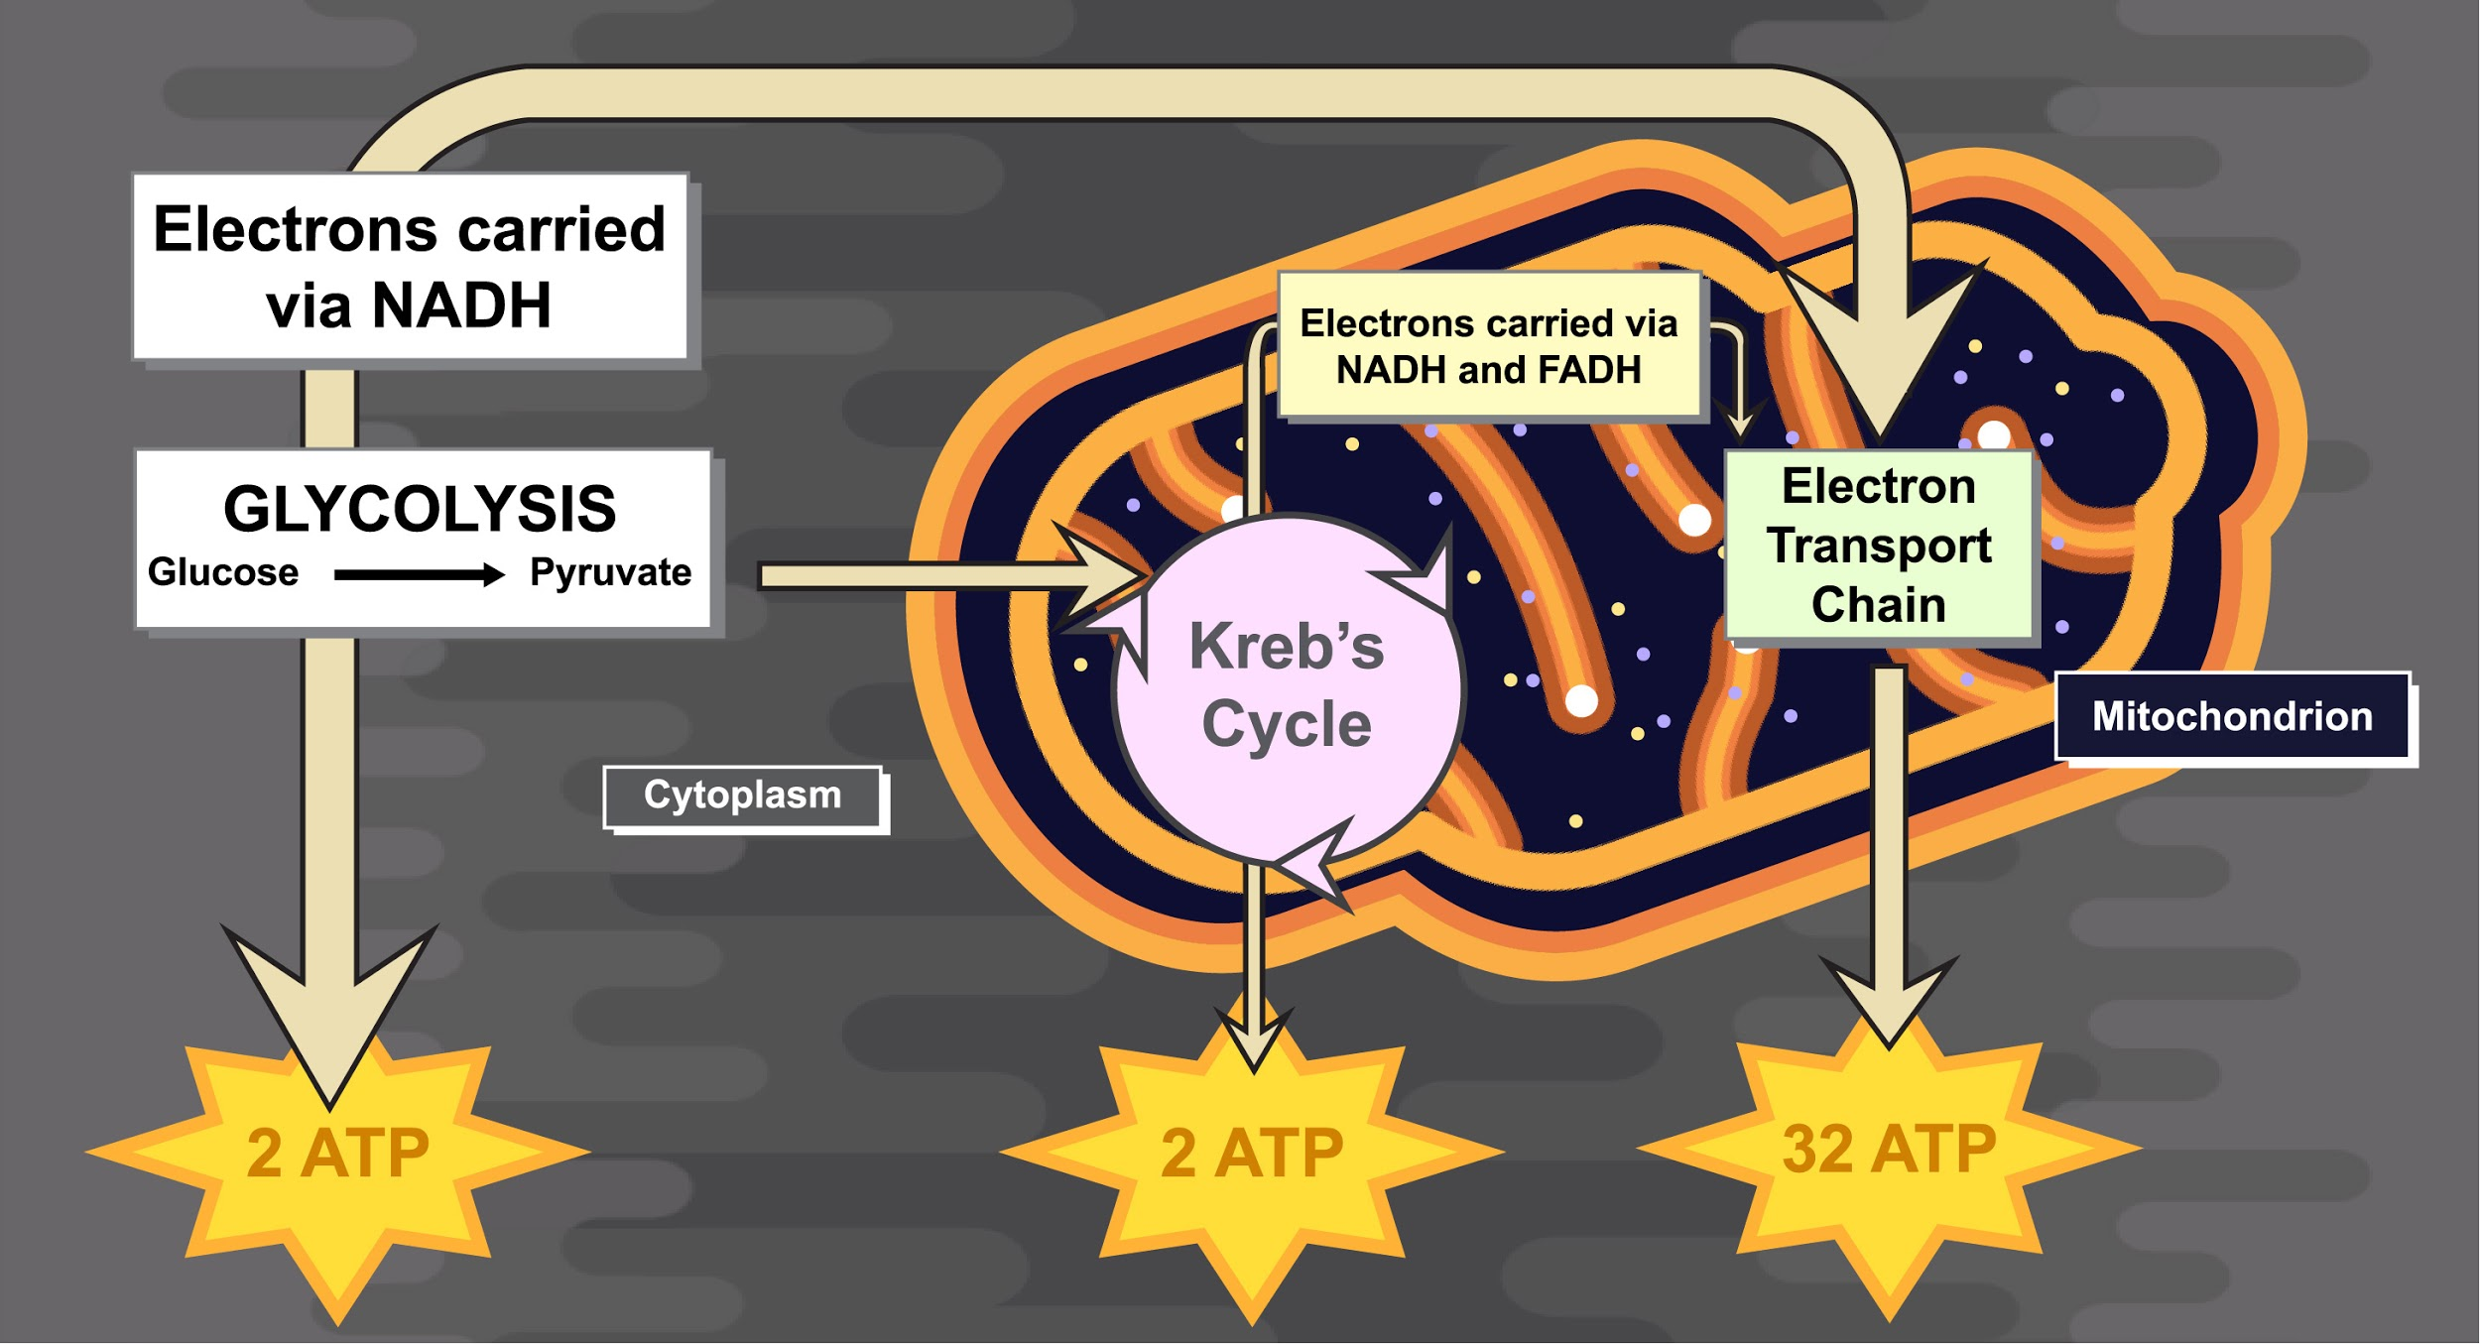
During the early history of life on Earth, there was little oxygen in the atmosphere. Scientists believe that glycolysis in early bacteria evolved as what we know today as fermentation, an anaerobic method to break down glucose to harvest chemical energy. Fermentation, therefore, provides a mechanism by which some cells can oxidize organic material and generate ATP without using oxygen. Fermentation allows for the oxidation of NADH (nicotinamide adenine dinucleotide + hydrogen) to NAD⁺, (nicotinamide adenine dinucleotide) which is necessary for glycolysis to go forward (Figure 2).
Figure 2. Fermentation
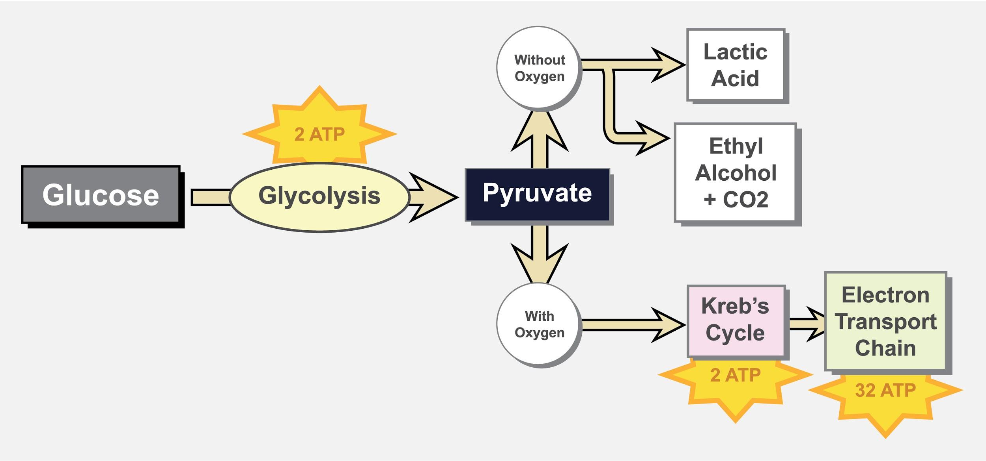
Today there are relatively few environments on our planet where oxygen is absent. Natural locations such as swamps and human-made structures, such as sewage treatment plants, harbor organisms that are incapable of growing in the presence of oxygen (obligate anaerobes).
There are also unicellular organisms that have evolved a method for surviving in the presence of oxygen while retaining the ability to thrive and reproduce in the absence of oxygen. These organisms are called facultative anaerobes and include the yeasts and many species of bacteria. Facultative anaerobes carry out fermentation when oxygen is absent and aerobic cellular respiration when oxygen is present.
One consequence of pollution of bodies of water by storm water, sewage and industrial or agricultural waste dumping, is eutrophication. In this process, nitrates, phosphates and other nutrients released into the water, promote the growth of algae. In still waters, the algae “bloom”, forming a layer, like a carpet, over the water surface.
Underwater plants die because of lack of light; the “blooming” algae also die. The organic matter resulting from this die off is used as a substrate for bacteria to get nutrients. Bacteria use up the oxygen in the water, as they use the organic molecules as source of energy, thus promoting “hypoxia”−low amounts of oxygen, and “anoxia”−no oxygen. Since there is no oxygen in the water, all aerobic organisms start dying off. Their cells can no longer produce ATP in the mitochondrion, and fermentation does not supply nearly enough energy for their survival.
Figure 3. Illustration of the process of eutrophication
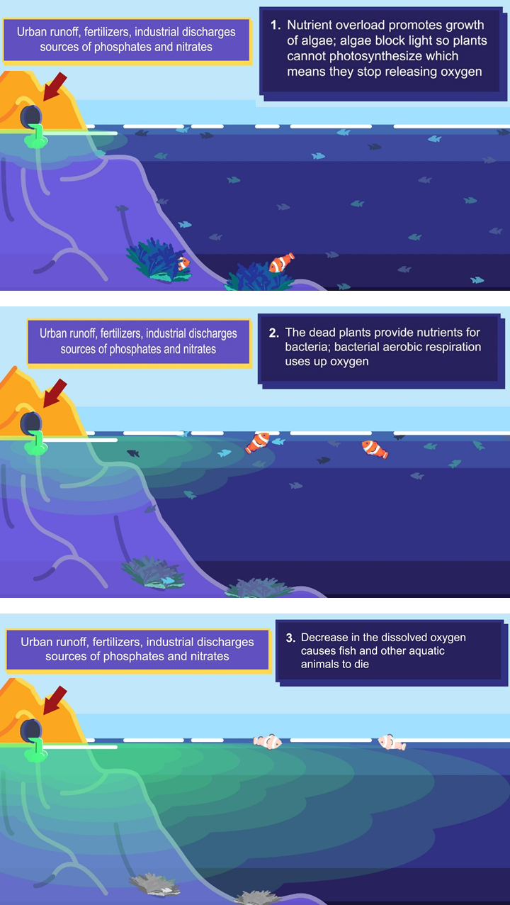

Procedures
Each group will work together to conduct the activities below. Every student must do all the calculations, record all the results and draw the graphs during the lab activity. Your instructor will write her initials once you have completed recording your results.
In alcoholic fermentation, remember glucose is first broken down to pyruvate in glycolysis. Pyruvate is then decarboxylated (i.e. a carboxyl group is removed) to acetaldehyde, which in turn is converted to ethanol (Figure 4).
Figure 4. Overall equation for the process of alcoholic fermentation starting with glucose
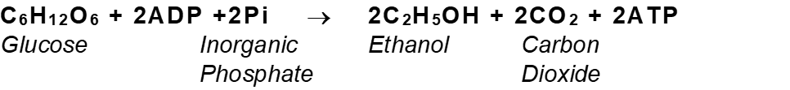

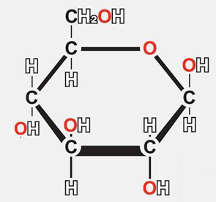

SECTION A: ALCOHOL FERMENTATION IN YEAST

Procedures:

Label the four falcon tubes with the yeast solutions and water
Falcon tube 1: Click/tap to enter. Water + yeast Click/tap to enter.
Falcon tube 2: Click/tap to enter. 5% glucose + yeast Click/tap to enter.
Falcon tube 3: Click/tap to enter. 7.5 % glucose + yeast Click/tap to enter.
Falcon tube 4: Click/tap to enter. 7.5% glucose + water Click/tap to enter.

Propose a hypothesis for the following:

What do you predict with respect to comparative fermentation rates for each of the three yeast solutions?
Hypothesis: Click or tap here to enter text.

Step 1:
- If it is not already done, mark each ml line on the cuvette with a permanent marker so the lines are visible when the yeast solutions are added (Figure 5a).
- Add 5 ml each from the labelled dispensers (#1 water, #2 -5% glucose, #3 -7.5% glucose, #4 7.5% glucose your chosen solutions recorded above) into the appropriate falcon tube (Figure 5a).

Step 2:
Stir the prepared yeast solution (which is in the 37 ºC water bath), then carefully pour your yeast solution into each falcon to the very brim. Remember each line represents 1ml.

Step 3:
Cap the tubes so that you feel them snap closed, cover the cap with your thumb and vigorously invert the cuvette 3 times to mix the yeast and the added solution.

Step 4:
Take the cap off and place 50 ml falcon tube over each 15 ml tube (Figure 5b)

Step 5:
Invert the falcon tubes, as seen in the picture. Place them in the holder and record the initial volume displaced (this would be time 0).

Step 6:
Begin measuring the amount of liquid displaced every 5 minutes for 30 minutes, and then every 10 min for another 10-20 min and write your results in Table 1.

Figure 5. Conical tube with 15 ml markings inverted into a 50 ml tube
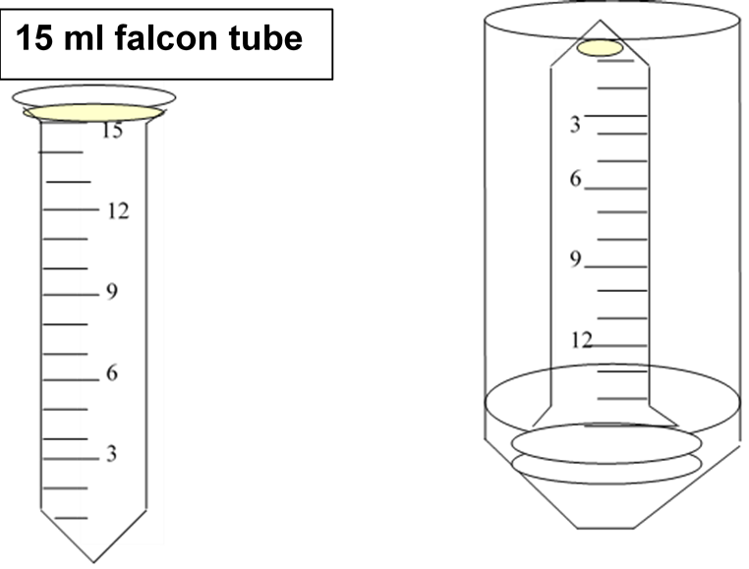

Table 1. Volume of liquid displaced by fermentation in water and chosen solutions
Time (min.) | Sample 1  (ml) | Sample 2  (ml) | Sample 3  (ml) | Sample 4  (ml)
0
5
10
15
20
25
30
40

Step 7:
Plot the ml displaced (Y-axis) for each condition vs. time (X-axis) on a piece of graph paper or use a spreadsheet program (Excel, Google Sheets, etc.). Write a title and label each axis. Insert the graph or image in the space under Question 1 below. Alternatively, attach the file with the graph when you submit this lab. For other options, contact the instructor.

Questions
- Graph the results for the different solutions. Place the CO₂ evolved on the Y axis and the time (minutes) on the X axis.
Copy and paste, upload or attach your graph.

- Calculate the average fermentation rate for each one of the solutions (ml CO₂ evolved/min.) The ml CO₂ evolved per minute can be calculated by examining the amount of fluid displaced per minute. (final – initial)/time elapsed)
Click/tap here to answer.
- Compare the fermentation rates of the three yeast solutions as well as the water solution.
- Was there a difference in the fermentation rates of your solutions? Is this what you expected? Explain.
Click/tap here to answer.
- Did you expect any fermentation to occur in sample #1? Sample #4? Why or why not?
Click/tap here to answer

SECTION B: DETERMINING PRESENCE OF FACULTATIVE ANAEROBIC BACTERIA IN YOUR WATER SAMPLE

Determining presence of coliform bacteria in your water samples
The intestinal tract of animals, including humans, harbor bacteria that are essential in maintaining health. On the other hand, many human pathogens (disease-producing agents) are also found in the intestines of humans who have been infected. These pathogens are released in the feces, together with other fecal components.
In this exercise, you will be testing for the presence of coliform bacteria, which are a group of bacteria found in fecal matter. Coliforms are facultative anaerobes and can ferment sugars, producing both carbon dioxide (gas) and acids.
You will be using a lactose phenol red broth with a Durham tube to determine water contamination with fecal coliforms, which ferment lactose with gas production.

Inoculation:
You will inoculate two tubes of lactose broth by using sterile plastic Pasteur pipettes and adding approximately 1 ml of your water sample to each tube.
Before opening the lids on the test tube, make sure you have all the materials you are going to need for the inoculation. It is important to work quickly in order to avoid contamination of your test tubes from other sources.
- Clean the tubes with ethanol and a paper towel. When holding the tubes, make sure to do so from the middle of the tube; do not pick up by the lids.
- Place your test tubes in a rack. Label each tubs with your name, date, and sample. In one tube, also label it as “anaerobic”. (This is the tube you will add mineral oil to after you have added the inoculum.)
- Loosen the caps in the test tubes but leave them on.
- Take one ml of your water sample and add it to the first tube. Close the screw cap.
- Repeat the procedure with the second tube labelled as “anaerobic.” After adding your sample, swirl the contents, place the tube back on the rack, and then add a small amount of mineral oil (about 0.5 ml) over the top of the liquid.
- Your samples will be incubated overnight, at 37 °C, and you will be able to record your results during the next lab session.

Answer the following questions:
- What is the purpose of the uninoculated control tubes used in this test?
Click/tap here to answer.
- All bacteria known as “enterics” are facultative anaerobes, which means they have both respiratory and fermentative enzymes. What color results would you expect in lactose media inoculated with enterics, in sealed and unsealed tubes? Explain
Click/tap here to answer.
- If you were to trace the origin of the atoms found in the CO₂ released during fermentation, where would you find them (in what compound)?
Click/tap here to answer.
- How much ATP is produced when one molecule of glucose is fermented?
Click/tap here to answer.
- When a water sample tests positive for coliform bacteria, what can be said about the original source of these types of bacteria (where are these bacteria normally found, and what is a reasonable explanation of how they got into the water body you are researching)?
Click/tap here to answer.
When glucose is depleted, cells can break down other carbohydrates as well as fat, and use them as a source of energy. To do this, cells need the right enzymes to catalyze the breakdown reactions.
In this section of the lab, you will be recording the results of culturing bacteria from your water sample, in broth with lactose, which is a disaccharide.
The broth has phenol red, which is a pH indicator. At neutral pH, the broth is red, it turns yellow when the broth becomes acidic.
Inside the tube, you will also observe another small tube called Durham tube. When gas is produced, bubbles will appear in the tube (Figure 6). Figure 6 shows three test tubes. The first two tubes are yellow, which indicates the media has turned acidic. The third tube is red, which indicates the media is neutral. The arrow in the first tube points to the bubble seen in the Durham tube, when gas is produced.

Figure 6. Results for lactose fermentation with gas production test
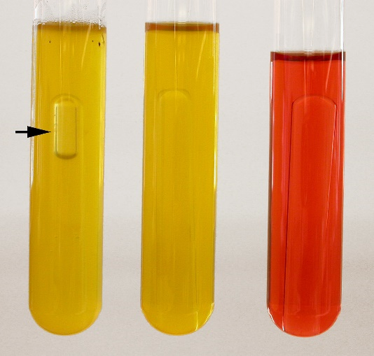

Recording results

Table 2. Results of lactose phenol-red broth + Durham tubes inoculated with water samples.
Name of sample* | Date of inoculation | Area of Collection | Color of broth | Gas Production  (yes/no) | Interpretation of results
Sample name | mm-dd-yyyy | Click/tap to enter. | Click/tap to enter. | Enter yes or no | Click/tap to enter.
Sample name | mm-dd-yyyy | Click/tap to enter. | Click/tap to enter. | Enter yes or no | Click/tap to enter.
Sample name | mm-dd-yyyy | Click/tap to enter. | Click/tap to enter. | Enter yes or no | Click/tap to enter.
*Copy label on your tube: aerobic, anaerobic, control.

Answer the following question:
- What is the purpose of adding phenol red to the broth in the tubes?
Click/tap here to answer Q.1

SECTION C. Determining the amount of dissolved oxygen in your sample

Materials:
- LaMotte oxygen titration kit
- Glass bottles with water samples
Aquatic animals, including vertebrates and invertebrates, as well as many protists and bacteria, require oxygen to live. In fact, all aerobic organisms, including plants, require oxygen for cellular respiration. Oxygen from the atmosphere dissolves in water, until it reaches saturation. The dissolved oxygen will diffuse throughout the water, depending on how much the water is aerated (rivers and oceans with currents are more aerated than still ponds).
Today you will be measuring the amount of dissolved oxygen in your water sample with a test kit (LaMotte) that uses the azide modification of the Winkler method for determining dissolved oxygen.

Collection of your water sample
- The water sample you will be testing was collected by your instructor by submerging the glass bottle in the water and immediately sealing it with the cap. Since oxygen in the air will dissolve in water, it is important to ensure the sample is not aerated after collection.

- After collecting the water, your instructor added two chemical reagents that will “fix” the oxygen present in the water. This will allow you to titrate the amount of dissolved oxygen in your water and compare it to standards set for different uses, by the Environmental Protection Agency (EPA).

Titration
Follow the procedure describe bellow. Before beginning your titration, make sure you have gone through the steps and have all the reagents and material you need. The procedure below is a modification of that provided by LaMotte.

TEST PROCEDURE

PART 3 - THE TITRATION

Step 1:
Fill the titration tube to the 20 ml line with the fixed sample. Cap the tube.
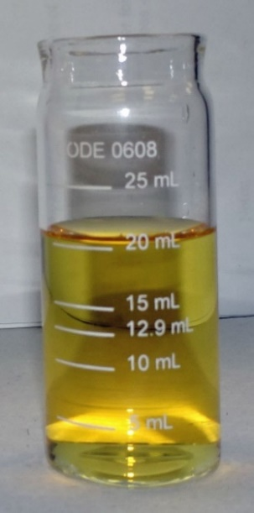

Step 2:
Depress plunger of the Titrator.
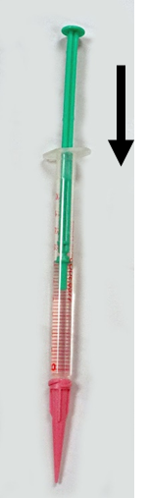

Step 3:
Insert the Titrator into the plug in the top of the *Sodium Thiosulfate, 0.025N titrating solution.
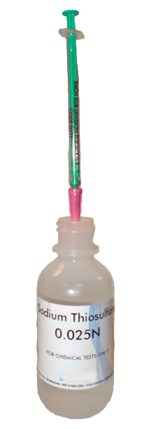

Step 4:
Invert the bottle and slowly withdraw the plunger until the large ring on the plunger is opposite the zero (0) line on the scale.
Step 4 hand withdrawing plunger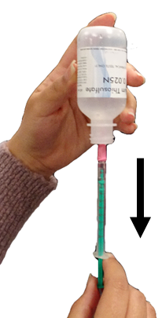
Note: If small air bubbles appear in the Titrator barrel, expel them by partially filling the barrel and pumping the titration solution back into the reagent container. Repeat until bubble disappear.

Step 5:
Turn the bottle upright and remove the Titrator.
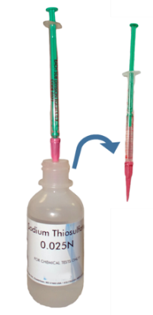
Note: If the sample is a very pale yellow go to Step 9
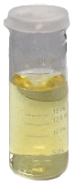

Step 6:
lnsert the tip of the Titrator into the opening of the titration tube cap.
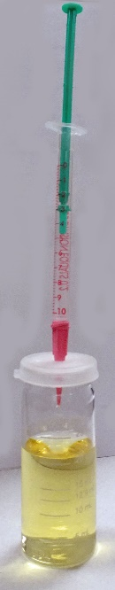

Step 7:
Slowly depress the plunger to dispense the titrating solution until the yellow brown color changes to a very pale yellow. Gently swirl the tube during the titration to mix the contents.
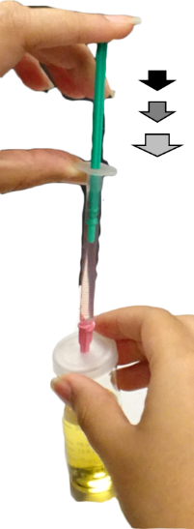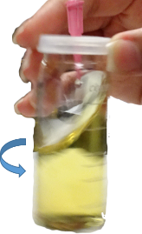

Step 8:
Carefully remove the Titrator and cap. Do not to disturb the Titrator plunger.
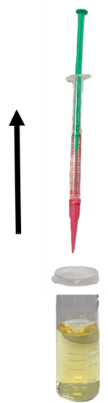

Step 9:
Add 8 drops of Starch Indicator Solution (4170WT). The sample should turn blue.
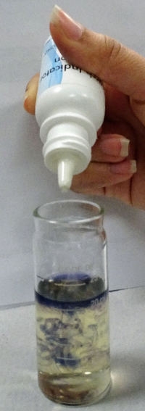

Step 10:
0.9
Cap the titration tube. Insert the tip of the Titrator into the opening of the titration tube cap.
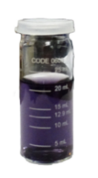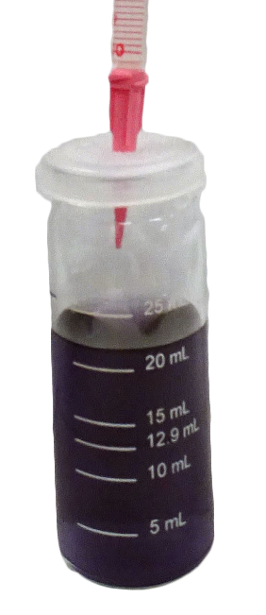

Step 11:
Continue titrating until the blue color disappear and the solution becomes colorless.
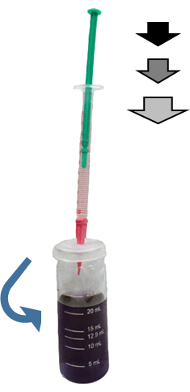
The colorless solution
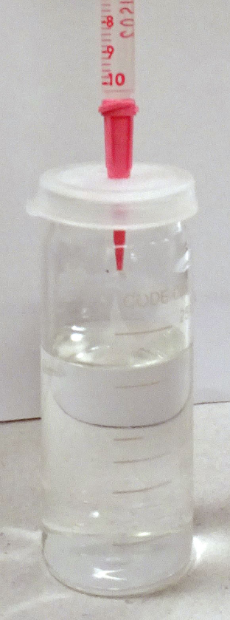

Step 12:
Read the test result directly from the scale where the large ring on the Titrator meets the Titrator barrel. Record a ppm Dissolved Oxygen. Each minor division on the Titrator scale equal 0.2 ppm.
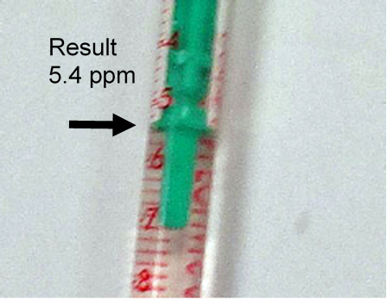
NOTE: lf the plunger ring reaches the bottom line on the scale (10 ppm) before the endpoint color change occurs, refill the Titrator and continue the titration. Include the value of the original amount of reagent dispensed (10 ppm) when recording the test result.
NOTE: When testing is complete, discard titrating solution in Titrator. Rinse Titrator and titration tube thoroughly. DO NOT remove plunger or adapter tip.

Record your results in the table below:

Table 4. Dissolved oxygen in water samples
determined by the azide modification of the Winkler method
Sample Name | Collection date | Time | Temp | pH | Oxygen saturation (ppm) | Levels considered appropriate for survival of most aquatic species | Levels considered stressful for most species | Levels considered fatal for most species
Sample name | mm-dd-yyyy | Temp | Time | pH | ppm | Enter level. | Enter level. | Enter level.

Answer the following questions:
- How does oxygen go into cells, give the name of the process and explain the factors that affect the movement of oxygen into a cell?
Click/tap here to answer
- What metabolic process directly requires oxygen in order to go forward?
Click/tap here to answer
- What is the exact role of oxygen in this process?
Click/tap here to answer
- Illustrate your answer for question 2 by making a drawing to explain how oxygen is involved in this process. Where in the cell and how does this process occur? Draw in the space provided. Alternatively, you can paste, upload or attach an image file.

To draw with pen/mouse, click here and press enter. Within the ribbon menu, click Insert and select Shapes and the Scribble line. Other options: copy and paste, upload or attach your drawing or contact instructor for a non-drawing option.

Notes:
Click/tap here to enter notes

First and last name:
Enter first and last name and save file (required)

Copyright and attribution
This work is licensed under a Creative Commons Attribution 4 International License. It was previously published as “Water in your neighbourhood: a model for implementing a semester-long course-based undergraduate research project in introductory biology,” in Education Inquiry, (2020) DOI:10.1080/20004508.2020.1716542 as an Open Access article with the Creative Commons Attribution-NonCommercial License. All figures have been modified.

