On the portal, when you are editing, click the three dots on the far right side. Scroll down to “Keyboard shortcuts”.
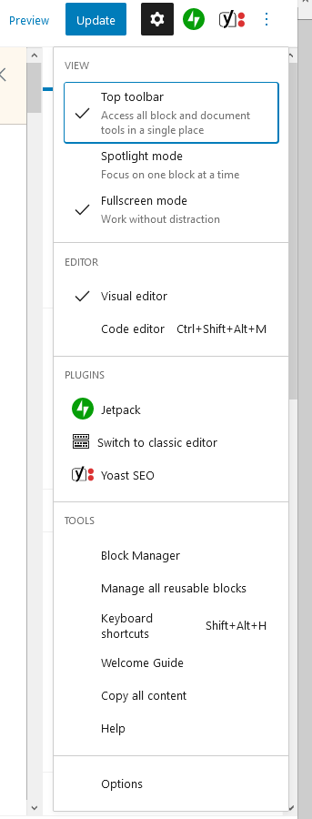

Keyboard shortcuts
Display these keyboard shortcuts.
Shift+Alt+H

Global shortcuts
Switch between visual editor and code editor.
Ctrl+Shift+Alt+M
Toggle fullscreen mode.
Ctrl+Shift+Alt+F
Open the block navigation menu.
Shift+Alt+O
Show or hide the settings sidebar.
Ctrl+Shift+,
Navigate to the next part of the editor.
Ctrl+`Shift+Alt+N
Navigate to the previous part of the editor.
Ctrl+Shift+`Shift+Alt+P
Navigate to the nearest toolbar.
Alt+F10
Save your changes.
Ctrl+S
Undo your last changes.
Ctrl+Z
Redo your last undo.
Ctrl+Shift+Z

Selection shortcuts
Select all text when typing. Press again to select all blocks.
Ctrl+A
Clear selection.
escape
Block shortcuts
Duplicate the selected block(s).
Ctrl+Shift+D
Remove the selected block(s).
Shift+Alt+Z
Insert a new block before the selected block(s).
Ctrl+Alt+T
Insert a new block after the selected block(s).
Ctrl+Alt+Y
Remove multiple selected blocks.
delbackspace
Move the selected block(s) up.
Ctrl+Shift+Alt+T
Move the selected block(s) down.
Ctrl+Shift+Alt+Y
Change the block type after adding a new paragraph.
/

Text formatting
Make the selected text bold.
Ctrl+B
Make the selected text italic.
Ctrl+I
Convert the selected text into a link.
Ctrl+K
Remove a link.
Ctrl+Shift+K
Underline the selected text.
Ctrl+U

